Candidate Information Pack

INVESTIGATION OFFICERS

Reference No: 08/2020

July 2020

Background to the role of Investigation Officer

Dear Applicant

Established under the Police (Northern Ireland) Act 1998, we exist to provide an independent and impartial police complaints system for the people of Northern Ireland. We receive and investigate complaints about the police made by members of the public, and also matters of public interest involving the Police Service of Northern Ireland (PSNI).

Investigation Officers report to a Deputy Senior Investigation Officer and will be responsible for the investigation of allocated cases.

The appointment will be made by the Police Ombudsman for Northern Ireland acting in accordance with his powers under the Police (Northern Ireland) Act 1998. Staff appointed under the Act will be employees of the Police Ombudsman and not civil servants.
The persons appointed in addition to the mandatory qualifications below, should have proven inter-personal skills and highly developed communication skills across a range of settings.

The appointees should also possess a full understanding of and commitment to the fundamental principles of human rights and a comprehensive understanding of the sensitive social, cultural and political environment within which the work of the Police Ombudsman operates.

Applicants will be required to demonstrate a range of general investigation competencies however the Office is particularly interested in hearing from those with a strong background in digital evidence and disclosure.

Please note: Successful applicants will be required to undertake PIP2 Accreditation Programme unless they are already accredited.

Successful applicants may require to have Article 2 compliance, depending on case allocation.

About the Police Ombudsman for Northern Ireland

The Police Ombudsman for Northern Ireland is appointed under Royal Warrant and is a corporation sole. Her statutory duty is to exercise her powers in such manner and to such extent as appears to her best calculated to secure the efficiency, effectiveness and independence of the police complaints system, and the confidence of the public and members of the police force in that system. She has responsibility for the Police Service of Northern Ireland (PSNI), ‘designated civilians’ working with the PSNI, Belfast Harbour Police, Larne Harbour Police, Belfast International Airport Police and the Ministry of Defence Police. By virtue of the Serious Organised Crime and Police Act 2005 she has responsibility for the investigation of allegations against members of staff of the National Crime Agency in Northern Ireland.

The Police Ombudsman receives and investigates complaints about the police made by members of the public, and also matters of public interest involving the PSNI. Where appropriate she makes recommendations in respect of criminal, disciplinary and misconduct matters, in respect of which she may also publish reports and make policy recommendations. In addition to this she has a power to investigate current police policy and practice, and to publish the results of any such investigation. She provides extensive statistical and management information to the Department of Justice, Chief Constable and Northern Ireland Policing Board.

In undertaking her statutory duties, the Police Ombudsman employs approximately 150 staff in a number of specialist and support roles. The budget for the Office is around £9m.

The RUC (Complaints etc) Regulations 2001 enables the Police Ombudsman to investigate serious legacy matters.

Further information about the organisation can be found at www.policeombudsman.org
Person specification
It is essential that the evidence provided by applicants includes sufficient details, which clearly demonstrate how they meet all of the Eligibility Criteria. This must include reference to specific examples of actions and achievements; it is not sufficient to provide simply a list of duties and responsibilities. Candidates should demonstrate a successful track record in relation to all specified fields.

Eligibility Criteria

Essential Criteria:

It is essential that candidates have:

- A degree level qualification and a minimum of 2 years’ working experience of managing criminal other legal enforcement investigations at all stages.

OR

In the absence of the educational qualification have a minimum of 4 years working experience of managing criminal or other legal enforcement investigation at all stages.

OR

A qualified solicitor or barrister with at least 2 years’ post qualification experience practising in a criminal law setting.

AND

- Experience in the writing of high quality evidence based reports including recommendations.

- Have experience in the use of IT systems in the working environment.

- Hold a current driving licence and have access to a car, which is available for official business, OR have access to a means of transport that will enable them to undertake the duties of the post in full.

Desirable Criteria

- Experience of presenting evidence under cross examination in a court or other legally empowered body.

- Experience in the use of digital media to assist in the investigation process.

- Operational experience in disclosure processes.

- Have successfully completed a training programme in Investigative Skills.

5.3 Shortlisting Arrangements

Applicants should be aware that after the initial eligibility sift, only where numbers necessitate it, the following criteria will be used in order to shortlist candidates further:

- Application of desirable criteria
Interview Assessment Criteria

KEY COMPETENCIES
In addition to satisfying the above eligibility criteria, applicants will also be
expected to display the following qualities and skills at interview:

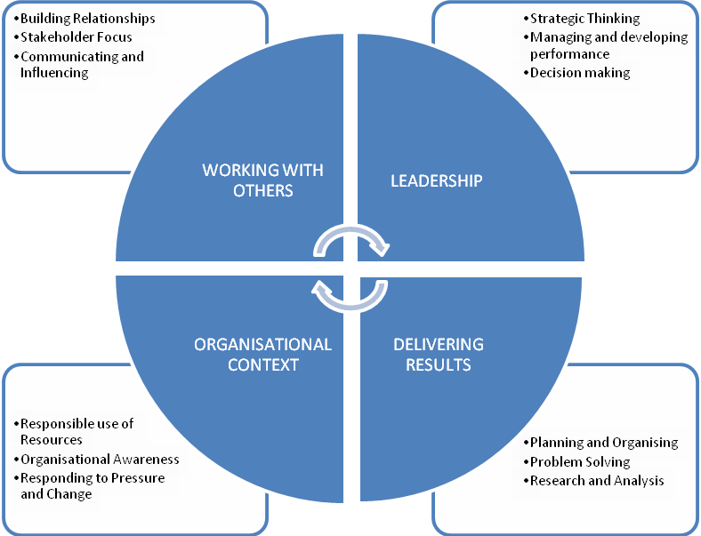

This role falls into the second competency level. The competency level appendix to this candidate information pack provides a guide to the behavioural indicators that indicate each competency.

The qualities and skills identified in the personnel specification above are considered essential to the position and will be tested as part of the selection and interview process.

Canvassing
Candidates should be aware that any attempts to enlist support for their application through any person except as referee named on the application forms will result in their application being disqualified.

Terms and conditions

Tenure

This is a permanent post.

Remuneration

The role is equivalent to Staff Officer Grade in the Northern Ireland Civil Service grading scale. The salary for the post is in the range £30,526 to £32,157. Starting salary will be £30,526 with progression in the salary range determined by performance in the post and subject to the review process agreed with the Northern Ireland Civil Service.
References, Security Clearance and Health Requirements
Appointment is subject of the receipt of satisfactory references, proof of identity checks and medical reports (where appropriate) and candidates should be aware that, if successful, they would be required to be vetted to SC level.
Hours of Work

The standard working week is 37 hours excluding meal breaks and the Office operates a Flexible Working Scheme (FWS).
The post holder will be expected to regularly perform ‘on-call’ duties via a rota system, which is remunerated.

Probation

The probationary period for this post is 12 months during which time your progress will be monitored. Provided a satisfactory standard is achieved and maintained, appointment will be confirmed for the duration of your contract. In the event of unsatisfactory progress your employment will not be regarded as confirmed and will be terminated either during or at the end of the probation period.

Successful applicants must be prepared to attend professional development courses as directed.

Annual Leave
In addition to the usual public and privilege holidays, appointees will receive 25 days annual leave per annum on appointment. The leave year runs from 1 February to 31 January. Successful candidates commencing employment during the leave year will receive a pro-rated leave entitlement.

Superannuation

The Office of the Police Ombudsman for Northern Ireland participates in the Principal Civil Service Pension Scheme (NI), which for new entrants starting from 01 April 2015 offers two types of pension choices:

Alpha – This is an occupational pension scheme that currently has a member contribution rate relating to salary (currently 5.45% in the salary range). As your employer we meet the rest of the cost of the scheme.

Partnership – This is a stakeholder pension with a contribution from ourselves. How much we pay is based on the appointees age and we pay this regardless of whether the appointee chooses to contribute anything. Appointee contributions are not compulsory but, if they occur, we as your employer will also match the appointees contributions up to 3% of their pensionable earnings. These contributions are in addition to the age related contribution mentioned above.

Notice

The notice you are entitled to receive and are required to give in the event of your termination of employment is as stated in your contract of employment/Statement of Main Terms and Conditions.

Retirement Age

Staff may, subject to normal efficiency and attendance requirements, elect to retire at any age from age 60. In line with the Employment Equality (Repeal of Retirement Age Provisions) (Northern Ireland) 2011 there is no compulsory retirement age.

Applications

Under Fair Employment legislation, the Police Ombudsman is required to monitor the community background of those applying to fill vacancies. Applicants should therefore complete the application form and return it together with the Equal Opportunities Monitoring Form.

The Police Ombudsman for Northern Ireland is committed to equality of opportunity in employment and welcomes applications from suitably qualified candidates irrespective of disability, gender, race, religious belief, political opinion or sexual orientation. All applications for employment are considered on the basis of merit.

This candidate information booklet should not be taken as constituting conditions of employment.

How to apply

To apply for this role, please complete and submit the application form and equal opportunities form.

Please note that CVs cannot be accepted as part of your application

The closing date for applications is Friday 7th August 2020 at 4.00pm.

If you have any queries about any aspect of the appointment process or need additional information please contact the Human Resources Department on 028 90 828722.

Recruitment timetable (subject to change)

Closing date | 7th August 2020 at 4.00pm
Shortlist meeting  Interview dates | w/c TBC  w/c TBC
Anticipated start date | TBC

