Candidate Information Pack

Senior Investigation Officer

Reference No: 05/2021

April 2021

Background to the role of Senior Investigation Officer

Dear Applicant

Established under the Police (Northern Ireland) Act 1998, we exist to provide an independent and impartial police complaints system for the people of Northern Ireland. We receive and investigate complaints about the police made by members of the public, and also matters of public interest involving the Police Service of Northern Ireland (PSNI).

The Senior Investigation Officer is responsible for ensuring that effective and efficient investigations are conducted by investigations staff. They will contribute to the development of excellence in the Directorate’s performance, in respect of both professional capabilities and the quality of customer service.

It is within this context that this role is required.

The appointment will be made by the Police Ombudsman for Northern Ireland acting in accordance with her powers under the Police (Northern Ireland) Act 1998. Staff appointed under the Act will be employees of the Police Ombudsman and are not civil servants. The appointment is a permanent contract.

The person appointed in addition to the mandatory qualifications below, should have proven inter-personal skills and highly developed communication skills across a range of settings.

The appointee should also possess a full understanding of and commitment to the fundamental principles of human rights and a comprehensive understanding of the sensitive social, cultural and political environment within which the work of the Police Ombudsman operates.

About the Police Ombudsman for Northern Ireland

The Police Ombudsman for Northern Ireland is appointed under Royal Warrant and is a corporation sole. Her statutory duty is to exercise her powers in such manner and to such extent as appears to her best calculated to secure the efficiency, effectiveness and independence of the police complaints system, and the confidence of the public and members of the police force in that system. She has responsibility for the Police Service of Northern Ireland (PSNI), ‘designated civilians’ working with the PSNI, Belfast Harbour Police, Belfast International Airport Police and the Ministry of Defence Police.

The Police Ombudsman receives and investigates complaints about the police made by members of the public, and also matters of public interest involving the PSNI. Where appropriate she makes recommendations regarding criminal and misconduct matters, in respect of which she may also publish statements and make policy recommendations. In addition to this she has a power to investigate current police policy and practice, and to publish the results of any such investigation. She provides extensive statistical and management information to the Department of Justice, Chief Constable and Northern Ireland Policing Board. In undertaking her statutory duties, the Police Ombudsman employs approximately 150 staff in a number of specialist and support roles. The budget for the Office is around £9m.

The RUC (Complaints etc) Regulations 2001 enables the Police Ombudsman to investigate serious legacy matters.

Further information about the organisation can be found at www.policeombudsman.org

Person specification

It is essential that the evidence provided by applicants include sufficient details, which clearly demonstrate how they meet all of the Eligibility Criteria. This must include reference to specific examples of actions and achievements; it is not sufficient to provide simply a list of duties and responsibilities. Candidates should demonstrate a successful track record in relation to all specified fields.

Essential Criteria:

It is essential that, by the closing date for receipt of completed applications (Friday 14th May 2021 at 4.00pm), candidates have:

- At least 3 years’ experience at a senior level, of conducting complex and sensitive investigations.

- At least 3 years’ experience in the management, leadership, development, motivation and direction of a team of investigators.

- Demonstrable experience of assessing and evaluating investigators undertaking an accredited investigative qualification process.

- Demonstrable experience of compiling comprehensive case files in respect of complex criminal investigations for consideration by the Prosecution Service.

- Demonstrable experience in the writing of reports, including those for publication.

- Hold a valid driving licence.

Desirable Criteria

- Hold an accredited qualification to PIP Level 3 or equivalent.

Short-listing Arrangements

Applicants should be aware that after the initial eligibility sift, only where numbers necessitate it, the desirable criteria will be used to shortlist further.

Interview Assessment Criteria

KEY COMPETENCIES
In addition to satisfying the above eligibility criteria, applicants will also be expected to display the following qualities and skills at interview:

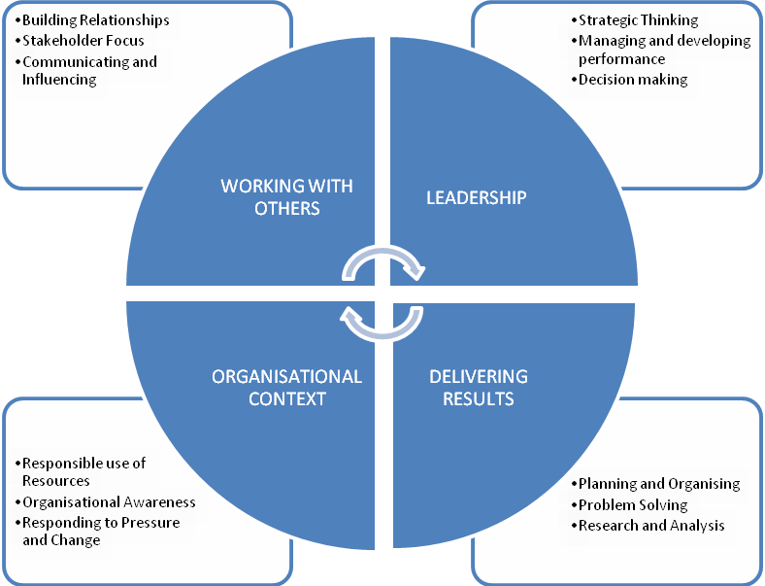

This role falls into the third competency level. The competency level appendix to this candidate information pack provides a guide to the behavioural indicators that indicate each competency.

The qualities and skills identified in the personnel specification above are considered essential to the position and will be tested as part of the selection and interview process.

Canvassing
Candidates should be aware that any attempts to enlist support for their application through any person except as referee named on the application forms will result in their application being disqualified.
Terms and Conditions

Tenure

This is a permanent post. A reserve list may be compiled for similar posts which arise over the next 12 months.

Remuneration

The role is equivalent to Grade 7 in the Northern Ireland Civil Service grading scale. The salary for the post is in the range £48,829 to £53,518. Starting salary will be £48,829 with progression in the salary range determined by performance in the post and subject to the review process agreed with the Northern Ireland Civil Service.

References, Security Clearance and Health Requirements
Appointment is subject of the receipt of satisfactory references, proof of identity checks and medical reports (where appropriate) and candidates should be aware that, if successful, they would be required to be vetted to SC level.
Hours of Work

The standard working week is 37 hours excluding meal breaks. The Office operates a Flexible Working Scheme (FWS). Occasional evening or weekend working may be required in line with business needs.
The Office is committed to equality and diversity consequently we are open to discuss with you how a flexible working pattern may meet your needs and those of the Office (such discussions will only take place at the conclusion of the assessment process).

Probation

The probationary period for this post is 12 months. Successful applicants must be prepared to attend professional development courses as directed.

Annual Leave
In addition to the usual public and privilege holidays, appointees will receive 25 days annual leave per annum on appointment. The leave year runs from 1 February to 31 January. Successful candidates commencing employment during the leave year will receive a pro-rated leave entitlement.
Superannuation

The Office of the Police Ombudsman for Northern Ireland participates in the Principal Civil Service Pension Scheme (NI), which for new entrants starting from 01 April 2015 offers two types of pension choices:

Alpha– This is an occupational pension scheme that currently has a member contribution rate relating to salary (currently 5.45% for the salary range of this post). As your employer we meet the rest of the cost of the scheme.
Partnership – This is a stakeholder pension with a contribution from ourselves. How much we pay is based on the appointees age and we pay this regardless of whether the appointee chooses to contribute anything. Appointee contributions are not compulsory but, if they occur, we as your employer will also match the appointees contributions up to 3% of their pensionable earnings. These contributions are in addition to the age related contribution mentioned above.

Notice

The notice you are required to give in the event of your resignation from employment is one month if less than one year’s service has been completed and three months if more than one year has been completed. Notice provided to you on termination of employment will be set out in the terms and conditions of employment.

Retirement Age

Staff may, subject to normal efficiency and attendance requirements, elect to retire at any age from age 60. In line with the Employment Equality (Repeal of Retirement Age Provisions) (Northern Ireland) 2011 there is no compulsory retirement age.

Applications

Under Fair Employment legislation, the Police Ombudsman is required to monitor the community background of those applying to fill vacancies. Applicants should therefore complete the application form and return it together with the Equal Opportunities Monitoring Form.

The Police Ombudsman for Northern Ireland is committed to equality of opportunity in employment and welcomes applications from suitably qualified candidates irrespective of disability, gender, race, religious belief, political opinion or sexual orientation. All applications for employment are considered on the basis of merit.

This Candidate Information Booklet should not be taken as constituting conditions of employment.

How to apply

To apply for this role, please complete and submit the application form.

Please note that CVs cannot be accepted as part of your application

The closing date for receipt of completed applications is Friday 14th May 2021 at 4.00pm.

If you have any queries about any aspect of the appointment process or need additional information please contact the Human Resources Department on 028 90 828662.

Recruitment timetable (subject to change)

Closing date | Friday 14th May 2021 at 4.00pm
Shortlist meeting  Interview dates | W/c: TBC  W/c: TBC
Anticipated start date | TBC

