Candidate Information Booklet

INVESTIGATION OFFICERS (HISTORIC CASES) FIXED TERM CONTRACT

Reference No: 06/2021

June 2021

Background to the role of Investigation Officer (Historic Cases)

Dear Applicant

Established under the Police (Northern Ireland) Act 1998, we exist to provide an independent and impartial police complaints system for the people of Northern Ireland. We receive and investigate complaints about the police made by members of the public, and also matters of public interest involving the Police Service of Northern Ireland (PSNI).

Since 2004 the volume of historic Complaints has significantly increased. In addition, the establishment of the PSNI’s Historical Enquiries Team (HET) in 2006 resulted in numerous referrals to the Police Ombudsman by the Chief Constable relating to incidents in which members of the RUC may have been responsible for deaths or where there may have been criminality or serious disciplinary misconduct by such officers.

The Historic cases currently held by the Police Ombudsman relate to deaths, including mostly murders, attempted murder and alleged miscarriages of justice, in connection with which members of the RUC may have been involved or are subject of allegations of criminality or serious misconduct.

It is within this context that these specialist Investigation Officer roles are required.

The appointment will be made by the Police Ombudsman for Northern Ireland acting in accordance with her powers under the Police (Northern Ireland) Act 1998. Staff appointed under the Act will be employees of the Police Ombudsman and not civil servants. The appointment is a temporary contract for a period of 18 months.
Appointments, which have primary responsibility for Investigations into allegations of police misconduct involving a death, will be conditional upon the successful candidate not having a past employment history which would conflict with the Office’s requirement to comply with Article 2 of the European Convention on Human Rights, (i.e. if that person was employed as a member of the RUC or served in a military regiment in support of the RUC during the period 1969 – 1998). A copy of the policy relating to this issue is enclosed with the application pack.

The persons appointed in addition to the mandatory qualifications below, should have proven interpersonal skills and highly developed communication skills across a range of settings.

The appointees should also possess a full understanding of and commitment to the fundamental principles of human rights and a comprehensive understanding of the sensitive social, cultural and political environment within which the work of the Police Ombudsman operates.

About the Police Ombudsman for Northern Ireland

The Police Ombudsman for Northern Ireland is appointed under Royal Warrant and is a corporation sole. Her statutory duty is to exercise her powers in such manner and to such extent as appears to her best calculated to secure the efficiency, effectiveness and independence of the police complaints system, and the confidence of the public and members of the police force in that system. She has responsibility for the Police Service of Northern Ireland (PSNI), ‘designated civilians’ working with the PSNI, Belfast Harbour Police, Larne Harbour Police, Belfast International Airport Police and the Ministry of Defence Police.

The Police Ombudsman receives and investigates complaints about the police made by members of the public, and also matters of public interest involving the PSNI. Where appropriate she makes recommendations regarding criminal and misconduct matters, in respect of which she may also publish statements and make policy recommendations. In addition to this she has a power to investigate current police policy and practice, and to publish the results of any such investigation. She provides extensive statistical and management information to the Department of Justice, Chief Constable and Northern Ireland Policing Board. In undertaking her statutory duties, the Police Ombudsman employs approximately 150 staff in a number of specialist and support roles. The budget for the Office is around £9m.

The RUC (Complaints etc) Regulations 2001 enables the Police Ombudsman to investigate serious legacy matters.

Further information about the organisation can be found at www.policeombudsman.org

Person Specification

It is essential that the evidence provided by applicants includes sufficient details, which clearly demonstrate how they meet all of the Eligibility Criteria. This must include reference to specific examples of actions and achievements; it is not sufficient to provide simply a list of duties and responsibilities. Candidates should demonstrate a successful track record in relation to all specified fields.

Eligibility Criteria

Essential Criteria:

- A minimum of 3 years’ experience in the investigation of serious crime or other legal enforcement investigations at all stages.

- Practical knowledge, experience and application of relevant legislation including the Police and Criminal Evidence Act (PACE), the Criminal Procedures and Investigations Act (CPIA), and the Regulation of Investigatory Powers Act (RIPA).

- Present no conflict of interest by virtue of previous employment history, which could impact on the Office’s ability to comply with Article 2 of the European Convention on Human Rights (see section 3 above and enclosed policy).

- Hold a valid driving licence that satisfies road traffic legislation in Northern Ireland and have access to a car which is available for official business OR, *have access to a means of transport that will enable the full range of duties of the post to be met.

*This relates only to any person who has declared that they have a disability which debars them from driving.

Desirable Criteria:

1. Expertise in a specific functional area considered relevant to the role e.g. MIR role, HOLMES 1&2, Investigative interviewing, File/Trial preparation including Disclosure, Serious Crime Review and the management, protection and dissemination of intelligence.

2. Experience of presenting evidence under cross examination in a court or other legally empowered body.

3. Have successfully completed an accredited investigative training programme.

Applicants should be aware that after the initial eligibility sift, only where numbers necessitate, the following criteria will be used in order to shortlist candidates further:

- Application of desirable criterion No. I above
- Application of desirable criterion No. 2 above
- Application of desirable criterion No. 3 above

Interview Assessment Criteria

KEY COMPETENCIES
In addition to satisfying the above eligibility criteria, applicants will also be expected to display the following qualities and skills at interview:

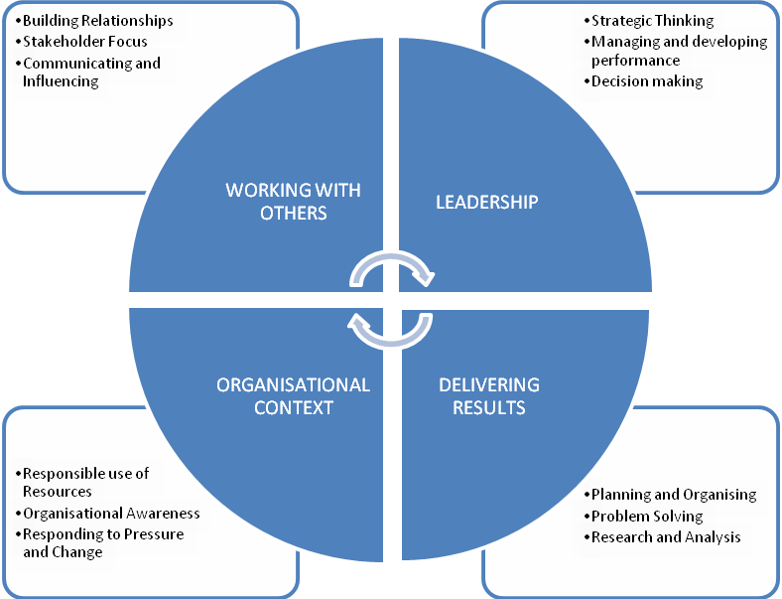

This role falls into the second competency level. The competency level appendix to this candidate information pack provides a guide to the behavioural indicators that indicate each competency.

The qualities and skills identified in the personnel specification above are considered essential to the position and will be tested as part of the selection and interview process.

Canvassing
Candidates should be aware that any attempts to enlist support for their application through any person except as referee named on the application forms will result in their application being disqualified.
Terms and Conditions

Tenure

This is a temporary post of 18 months. Due to the temporary nature of the post the tenure is subject to continuing sponsored funding and ongoing regular review.

Remuneration

The salary for the post is in the range £31,137 to £32,800. Starting salary will be £31,137 with progression in the salary range determined by performance in the post and subject to the review process agreed by the Northern Ireland Civil Service.

Successful candidates who currently permanently reside in Great Britain will be eligible for financial assistance towards the cost of temporary accommodation in Northern Ireland during the period of the appointment and the cost of travel to and from their permanent residence.

References, Security Clearance and Health Requirements

Appointment is subject of the receipt of satisfactory references, proof of identity checks and medical reports (where appropriate) and candidates should be aware that, if successful, they would be required to be vetted to Security Cleared (SC) level.

Hours of Work

The standard working week is 37 hours excluding meal breaks and the Office does operate a Flexible Working Scheme (FWS). Staff in the Investigation Directorate will, due to the nature of their work, be required on occasion to work outside normal office hours.

Probation

The probationary period for this post is 12 months. Successful applicants must be prepared to attend professional development courses as directed.

Annual Leave
In addition to the usual public and privilege holidays, appointees will receive 25 days annual leave per annum on appointment. The leave year runs from 1 February to 31 January. Successful candidates commencing employment during the leave year will receive a pro-rated leave entitlement.

Superannuation

The Office of the Police Ombudsman for Northern Ireland participates in the Principal Civil Service Pension Scheme (NI), which for new entrants starting from 01 April 2015 offers two types of pension choices:

Alpha– This is an occupational pension scheme that currently has a member contribution rate relating to salary (currently 5.45% in the salary range). As your employer the Office meets the rest of the cost of the scheme.

Partnership – This is a stakeholder pension with a contribution from ourselves. How much the Office pays is based on the appointee’s age and we pay this regardless of whether the appointee chooses to contribute anything. Appointee contributions are not compulsory but, if they occur, the Office as your employer will also match the appointee’s contributions up to 3% of their pensionable earnings. These contributions are in addition to the age related contribution mentioned above.

Notice

The notice you are entitled to receive and are required to give in the event of your termination of employment is one month.

Retirement Age

Staff may, subject to normal efficiency and attendance requirements, elect to retire at any age from age 60. In line with the Employment Equality (Repeal of Retirement Age Provisions) (Northern Ireland) 2011 there is no compulsory retirement age.

Applications

Under Fair Employment legislation, the Police Ombudsman is required to monitor the community background of those applying to fill vacancies. Applicants should therefore complete the application form and return it together with the Equal Opportunities Monitoring Form.

The Police Ombudsman for Northern Ireland is committed to equality of opportunity in employment and welcomes applications from suitably qualified candidates irrespective of disability, gender, race, religious belief, political opinion or sexual orientation. All applications for employment are considered on the basis of merit.

This job specification should not be taken as constituting conditions of employment.
How to apply

To apply for this role, please complete and submit the application form.

Please note that CVs cannot be accepted as part of your application

The closing date for applications is Friday 25th June 2021 at 4.00pm

If you have any queries about any aspect of the appointment process or need additional information please contact the Human Resources Department on 028 9082 8632.

Recruitment timetable (subject to change)

Closing date | 25th June 2021
Shortlist meeting  Interview dates | Week Commencing 28th June 2021  Week Commencing 19th July 2021
Anticipated start date | October 2021

