Candidate information pack

Human Resources Manager

Reference No: 14/2019

June 2019

Background to the role of Human Resources Manager

Dear Applicant

Established under the Police (Northern Ireland) Act 1998, we exist to provide an independent and impartial police complaints system for the people of Northern Ireland. We receive and investigate complaints against the police made by members of the public, and also matters of public interest involving the Police Service of Northern Ireland (PSNI).

The Human Resources Manager reports to the Director of Corporate Services and is responsible for the provision of all strategic and transactional people management services for the Office, designed to produce a high performing organisation through people. The role has specific responsibility for recruitment & selection, payroll, learning & development, employee relations, performance management and health, safety & wellbeing.

It is within this context that this role is required.

The appointment will be made by the Police Ombudsman for Northern Ireland acting in accordance with his powers under the Police (Northern Ireland) Act 1998. Staff appointed under the Act will be employees of the Police Ombudsman and not civil servants. The appointment is a permanent contract.

The person appointed in addition to the mandatory qualifications below, should have proven inter-personal skills and highly developed communication skills across a range of settings.

The appointee should also possess a full understanding of and commitment to the fundamental principles of human rights and a comprehensive understanding of the sensitive social, cultural and political environment within which the work of the Police Ombudsman operates.

About the Police Ombudsman for Northern Ireland

The Police Ombudsman for Northern Ireland is appointed under Royal Warrant and is a corporation sole. His statutory duty is to exercise his powers in such manner and to such extent as appears to him best calculated to secure the efficiency, effectiveness and independence of the police complaints system, and the confidence of the public and members of the police force in that system. He has responsibility for the Police Service of Northern Ireland (PSNI), ‘designated civilians’ working with the PSNI, Belfast Harbour Police, Belfast International Airport Police and the Ministry of Defence Police.

The Police Ombudsman receives and investigates complaints against the police made by members of the public, and also matters of public interest involving the PSNI. Where appropriate he makes recommendations regarding criminal and misconduct matters, in respect of which he may also publish statements and make policy recommendations. In addition to this he has a power to investigate current police policy and practice, and to publish the results of any such investigation. He provides extensive statistical and management information to the Department of Justice, Chief Constable and Northern Ireland Policing Board. In undertaking his statutory duties, the Police Ombudsman employs approximately 150 staff in a number of specialist and support roles. The budget for the Office is around £9m.

The RUC (Complaints etc) Regulations 2001 enables the Police Ombudsman to investigate serious legacy matters.

Further information about the organisation can be found at www.policeombudsman.org

Role Description

Responsibility and Reporting Arrangements

Reports to Director of Corporate Services

Duties and responsibilities of the role

- Provide the Senior Management Team with advice and guidance on HR practice, policy and procedures, which contributes to the achievement of corporate goals.
- Provide effective leadership to the HR team in the provision of all HR services, acting as a role model to enhance team and individual development, capability and performance.
- Develop a HR Strategy and annual HR Plans to support the delivery of organisational objectives.
- Contribute to organisational design and change management programmes.
- Ensure that all recruitment and selection processes are timely, utilise effective assessment methodology and lead to the appointment of a high quality candidate in a fair and equitable manner.
- Review existing HR policies and procedures ensuring they are fit for purpose, reflecting best practice in the profession and compliant with current statutory requirements.
- Design new HR policies and procedures which support the delivery of the strategic HR direction.
- Oversee the management of the payroll and pension function, ensuring that employees receive the correct salary at the right time and that all employer and employee PAYE and pension contributions are accurately paid on time.
- Ensure that sickness absence is managed effectively and within target levels.
- Provide advice and guidance to managers, employees and their representatives on the application of the discipline and grievance procedures of the Office.
- Ensure compliance with the monitoring, reporting and other requirements of the Fair Employment and Treatment Order (Amendment) Regulations (NI) 2003.
- Oversee the control and management of Health & Safety risks associated with the activities of the Office and chair the Office Health & Safety Committee.
- Act as lead point of contact with the Trade Unions recognised by the Office and maintain the effectiveness of the Joint Negotiating and Consultative Committee (JNCC).
- Take the lead role in consulting, negotiating and implementing changes to employee terms and conditions of employment.
- Take the lead role in maintaining the Office’s Investors in People (IiP) accreditation.
- Oversee the effectiveness of the annual Performance Management process.
- Lead the implementation of an effective employee reward and recognition system.
- Ensure that the Learning and Development needs of employees (and the organisation generally) are indentified and that appropriate L&D interventions are planned, implemented and evaluated, to foster a learning culture throughout the organisation.
- Work to strengthen the engagement employees have with their work, colleagues and the Office to ensure they are more fulfilled by their work thus contributing to organisational objectives
- Ensure that all HR activities are designed and implemented with the Office Values and Code of Ethics in mind.
- Any other relevant duties appropriate to the grade as may be required including the participation in the interchange of duties within the Directorate.

Person specification

It is essential that the evidence provided by applicants includes sufficient details, which clearly demonstrate how they meet all of the Eligibility Criteria. This must include reference to specific examples of actions and achievements; it is not sufficient to provide simply a list of duties and responsibilities. Candidates should demonstrate a successful track record in relation to all specified fields.

Eligibility Criteria

Essential Criteria:

It is essential that, by the closing date for applications candidates have:

- A degree level qualification
- Chartered Membership of the Chartered Institute of Personnel and Development (MCIPD)
- A minimum of 3 years management level* experience in a generalist human resources role
- Demonstrable experience in the design, development and implementation of a variety of HR policies and associated procedures
- Demonstrable experience in the management of all aspects of the recruitment and selection process from vacancy initiation procedures to the induction stage
- Demonstrable experience in providing advice to managers on discipline and grievance issues and effectively guiding them through the appropriate processes
- Demonstrable knowledge of employment law relevant to all aspects of the employer/employee relationship

Short-listing Arrangements

Applicants should be aware that after the initial eligibility sift, only where numbers necessitate it, the following criteria will be used in order to shortlist candidates further:

- Increase the number of year’s management level experience in a generalist human resources role from 3 to 5.
- The strength and depth of experience across the range of essential criteria

*Management level experience means supervising the work of at least one other team member within a human resources function and being directly responsible for monitoring and assessing their job performance.
Interview Assessment Criteria

KEY COMPETENCIES
In addition to satisfying the above eligibility criteria, applicants will also be expected to display the following qualities and skills at interview:

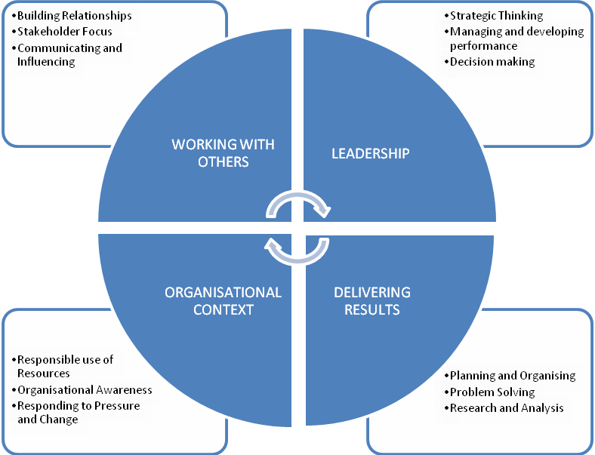

This role falls into the third competency level. The competency level appendix to this candidate information pack provides a guide to the behavioural indicators that indicate each competency.

The qualities and skills identified in the personnel specification above are considered essential to the position and will be tested as part of the selection and interview process.

Canvassing
Candidates should be aware that any attempts to enlist support for their application through any person except as referee named on the application forms will result in their application being disqualified.
Terms and conditions

Tenure

This is a permanent post.

Remuneration

The role is equivalent to Deputy Principal in the Northern Ireland Civil Service grading scale. The salary for the post is in the range £36,812 to £40,473. Starting salary will be £36,812 with progression in the salary range determined by performance in the post and subject to the review process agreed with the Northern Ireland Civil Service.

References, Security Clearance and Health Requirements
Appointment is subject of the receipt of satisfactory references, proof of identity checks and medical reports (where appropriate) and candidates should be aware that, if successful, they would be required to be vetted to SC level.
Hours of Work

The standard working week is 37 hours excluding meal breaks. The Office operates a Flexible Working Scheme (FWS). Occasional evening or weekend working may be required in line with business needs.

Probation

The probationary period for this post is 12 months. Successful applicants must be prepared to attend professional development courses as directed.

Annual Leave
In addition to the usual public and privilege holidays, appointees will receive 25 days annual leave per annum on appointment. The leave year runs from 1 February to 31 January. Successful candidates commencing employment during the leave year will receive a pro-rated leave entitlement.

Superannuation

The Office of the Police Ombudsman for Northern Ireland participates in the Principal Civil Service Pension Scheme (NI), which for new entrants starting from 01 April 2015 offers two types of pension choices:

Alpha– This is an occupational pension scheme that currently has a member contribution rate relating to salary (currently 5.45% for the salary range of this post). As your employer we meet the rest of the cost of the scheme.
Partnership – This is a stakeholder pension with a contribution from ourselves. How much we pay is based on the appointees age and we pay this regardless of whether the appointee chooses to contribute anything. Appointee contributions are not compulsory but, if they occur, we as your employer will also match the appointees contributions up to 3% of their pensionable earnings. These contributions are in addition to the age related contribution mentioned above.

Notice

The notice you are required to give in the event of your resignation from employment is one month if less than one year’s service has been completed and three months if more than one year has been completed. Notice provided to you on termination of employment will be set out in the terms and conditions of employment.

Retirement Age

Staff may, subject to normal efficiency and attendance requirements, elect to retire at any age from age 60. In line with the Employment Equality (Repeal of Retirement Age Provisions) (Northern Ireland) 2011 there is no compulsory retirement age.

Applications

Under Fair Employment legislation, the Police Ombudsman is required to monitor the community background of those applying to fill vacancies. Applicants should therefore complete the application form and return it together with the Equal Opportunities Monitoring Form.

The Police Ombudsman for Northern Ireland is committed to equality of opportunity in employment and welcomes applications from suitably qualified candidates irrespective of disability, gender, race, religious belief, political opinion or sexual orientation. All applications for employment are considered on the basis of merit.

This job specification should not be taken as constituting conditions of employment.

How to apply

To apply for this role, please complete and submit the application form.

Please note that CVs cannot be accepted as part of your application

The closing date for applications is Friday 05 July 2019

If you have any queries about any aspect of the appointment process or need additional information please contact the Human Resources Department on 028 90 828622.

Recruitment timetable (subject to change)

Closing date | Friday 05 July 2019
Shortlist meeting  Interview dates | W/c 15 July 2019  26 July 2019
Anticipated start date | Pending Security Clearance

