Candidate Information Pack

INVESTIGATION OFFICER (HISTORIC CASES) FIXED TERM CONTRACT
12 months

Reference No: 04/2023

March 2023

Background to the role of Investigation Officer (Historic Cases)

Dear Applicant

Established under the Police (Northern Ireland) Act 1998, we exist to provide an independent and impartial police complaints system for the people of Northern Ireland. We receive and investigate complaints against the police made by members of the public, and also matters of public interest involving the Police Service of Northern Ireland (PSNI).

Since 2004 the volume of historic Complaints has significantly increased. In addition, the establishment of the PSNI’s Historical Enquiries Team (HET) in 2006 resulted in numerous referrals to the Police Ombudsman by the Chief Constable relating to incidents in which members of the RUC may have been responsible for deaths or where there may have been criminality or serious disciplinary misconduct by such officers.

The Historic cases currently held by the Police Ombudsman relate to deaths, including mostly murders, attempted murder and alleged miscarriages of justice, in connection with which members of the RUC may have been involved or are subject of allegations of criminality or serious misconduct.

It is within this context that these specialist Investigation Officer roles are required.

The appointment will be made by the Police Ombudsman for Northern Ireland acting in accordance with her powers under the Police (Northern Ireland) Act 1998. Staff appointed under the Act will be employees of the Police Ombudsman and not civil servants. The appointment is a temporary contract for a period of 18 months.
Appointments, which have primary responsibility for Investigations into allegations of police misconduct involving a death, will be conditional upon the successful candidate not having a past employment history which would conflict with the Office’s requirement to comply with Article 2 of the European Convention on Human Rights, (i.e. if that person was employed as a member of the RUC or served in a military regiment in support of the RUC during the period 1969 – 1998). A copy of the policy relating to this issue is enclosed with the application pack.

The persons appointed in addition to the mandatory qualifications below, should have proven inter-personal skills and highly developed communication skills across a range of settings.

The appointees should also possess a full understanding of and commitment to the fundamental principles of human rights and a comprehensive understanding of the sensitive social, cultural and political environment within which the work of the Police Ombudsman operates.

About the Police Ombudsman for Northern Ireland

The Police Ombudsman for Northern Ireland is appointed under Royal Warrant and is a corporation sole. Her statutory duty is to exercise her powers in such manner and to such extent as appears to her best calculated to secure the efficiency, effectiveness and independence of the police complaints system, and the confidence of the public and members of the police force in that system. She has responsibility for the Police Service of Northern Ireland (PSNI), ‘designated civilians’ working with the PSNI, Belfast Harbour Police, Larne Harbour Police, Belfast International Airport Police and the Ministry of Defence Police.

The Police Ombudsman receives and investigates complaints about the police made by members of the public, and also matters of public interest involving the PSNI. Where appropriate she makes recommendations regarding criminal and misconduct matters, in respect of which she may also publish statements and make policy recommendations. In addition to this she has a power to investigate current police policy and practice, and to publish the results of any such investigation. She provides extensive statistical and management information to the Department of Justice, Chief Constable and Northern Ireland Policing Board. In undertaking her statutory duties, the Police Ombudsman employs approximately 150 staff in a number of specialist and support roles. The budget for the Office is around £9m.

The RUC (Complaints etc) Regulations 2001 enables the Police Ombudsman to investigate serious legacy matters.

Further information about the organisation can be found at www.policeombudsman.org

Person specification

It is essential that the evidence provided by applicants includes sufficient details, which clearly demonstrate how they meet all of the Eligibility Criteria. This must include reference to specific examples of actions and achievements; it is not sufficient to provide simply a list of duties and responsibilities. Candidates should demonstrate a successful track record in relation to all specified fields.

Eligibility Criteria

Essential Criteria:

- A minimum of 3 years’ experience in the investigation of serious crime or other legal enforcement investigations at all stages.

- Practical knowledge, experience and application of relevant legislation including the Police and Criminal Evidence Act (PACE), the Criminal Procedures and Investigations Act (CPIA), and the Regulation of Investigatory Powers Act (RIPA).

- Present no conflict of interest by virtue of previous employment history, which could impact on the Office’s ability to comply with Article 2 of the European Convention on Human Rights.

- Possess excellent communication skills with ability to listen and be empathetic.

- Have the ability to prioritise and plan work and investigations.

- Hold a full current driving license valid for use in the UK and have access to a car on appointment.*

*Where disability prohibits driving, this criteria will be waived if the applicant is able to organise suitable alternative arrangements.’

Desirable Criteria:

1. Expertise in a specific functional area considered relevant to the role e.g. MIR role, HOLMES 1&2, Investigative interviewing, File/Trial preparation including Disclosure, Serious Crime Review and the management, protection and dissemination of intelligence.

2. Experience of presenting evidence under cross examination in a court or other legally empowered body.

3. Have successfully completed an accredited investigative training programme.

Short-listing Arrangements

Applicants should be aware that after the initial eligibility sift, only where numbers necessitate it, the following criteria will be used in order to shortlist candidates further:

- Application of desirable criteria 1.
- Application of desirable criteria 2.
- Application of desirable criteria 3.

Interview Assessment Criteria

KEY COMPETENCIES
In addition to satisfying the above eligibility criteria, applicants will also be expected to display the following qualities and skills at interview:

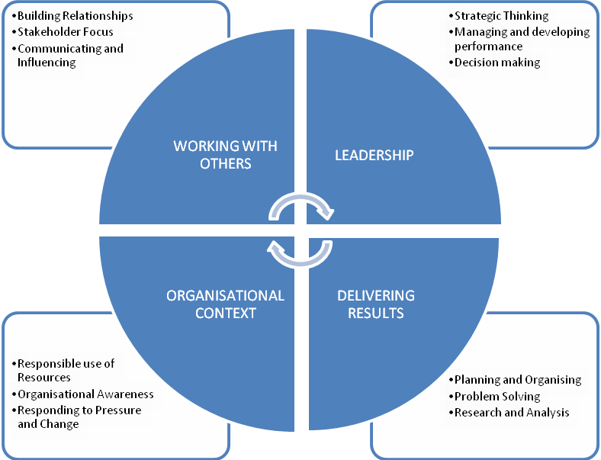

This role falls into the second competency level. The competency level appendix to this candidate information pack provides a guide to the behavioural indicators that indicate each competency.

The qualities and skills identified in the personnel specification above are considered essential to the position and will be tested as part of the selection and interview process.

Canvassing
Candidates should be aware that any attempts to enlist support for their application through any person except as referee named on the application forms will result in their application being disqualified.

Terms and conditions

Tenure

This is a fixed term post of 12 months. Due to the temporary nature of the post the tenure is subject to continuing sponsored funding and ongoing regular review.

Remuneration

The salary for the post is in the range £32,328 to £33,459. Starting salary will be £32,328 with progression in the salary range determined by performance in the post and subject to the review process agreed by the Northern Ireland Civil Service.

Successful candidates who currently permanently reside in Great Britain will be eligible for financial assistance towards the cost of temporary accommodation in Northern Ireland during the period of the appointment and the cost of travel to and from their permanent residence.
Accommodation
An allowance will be paid in respect of receipted rented accommodation costs (inclusive of rates) up to a maximum of a net amount of £700 per month. Actual costs incurred will be reimbursed up to £700, which means that should rent be incurred at a lesser rate, the lesser amount only can be claimed and should rent be incurred at a higher rate the re-imbursement will be capped at £700 net. It should be noted that the allowance is considered to be a taxable emolument. It will be paid to the individual via payroll, and subject to income tax and national insurance deductions through PAYE at the rate appropriate to the employees’ tax code as notified by HMRC. However, the Office will gross up the amount of the allowance to generate a net pay amount.
A further allowance will be paid in respect of receipted utility expenses actually incurred up to a maximum of a net amount of £100 per month. Utilities are described as electricity, gas or heating oil in respect of a heating system and a telephone land line rental (excludes call charges, broadband connection or other multi-media costs). As with rent it is the actual costs that will be reimbursed. It should be noted that the allowance is considered to be a taxable emolument. It will be paid via payroll and subject to income tax and national insurance deductions through PAYE at the rate appropriate to the employees’ tax code as notified by HMRC. However, the Office will gross up the amount of the allowance to generate a net pay amount.

Flights

An allowance will also be paid in respect of receipted flights to and from GB in order that the employee may maintain reasonable contact with their family during the assignment.

The allowance paid will be up to a maximum of a net amount of £400 per month and is limited to the use of economy class flights to GB. There can be no carry over of flight entitlement from month to month. Flights can only be used by the individual employee or their spouse or partner. As with rent and utilities, actual costs incurred will be re-imbursed up to the limit. It should be noted that the allowance is considered to be a taxable emolument. It will be paid via payroll and will be subject to income tax and national insurance deductions through PAYE at the rate appropriate to the employees’ tax code as notified by HMRC. However, the Office will gross up the amount of the allowance to generate a net pay amount.

The Office is aware that, dependant on your personal circumstances, the gross up of allowances through payroll at the prevailing taxation code applicable to your employment with the Office may, when combined with income you have from other sources, result in a liability for taxation on you following the end of a tax year.
Should you consider that these circumstances apply to you, we will ask you to provide information in support of any claim you might make, including but not limited to detail of any pension income or income from other sources. This is in order that a calculation can be made of the amount of taxation which has arisen as a consequence of the gross up of allowances to enable an arrangement to settle this liability.

Flexibility

The Office has a responsibility to safeguard public funds and considers that the allowances as set out provide reasonable assistance. Therefore requirements for flexibility are expected to be rare and in all cases should be supported by a clear and justifiable rationale. Should an employee consider that they have a particular need whereby they require a slightly higher allowance for travel than for accommodation or vice versa, then it may be possible to adjust the allowance package. Each matter will be considered on a case by case basis but under no circumstance will the overall amount of allowance exceed £1,200 per month. A request for flexibility should be submitted to the HR Manager but is subject to approval by the Director of Corporate Services. Such an arrangement must be determined at the outset of the assignment and cannot be changed at a later date.

These allowances are only payable if the employee confirms that they need to retain and maintain a permanent residence in GB. If the employee sells or sub-lets their normal residence in GB whilst engaged in the above project then the allowance will no longer be payable. Similarly if the employee relocates to Northern Ireland the allowance will not be paid. All changes of circumstances in respect of residence and entitlement to these allowances must be immediately brought to the attention of the HR Manager.

Failure to notify the HR Manager of any pertinent changes to circumstances and any falsification of information associated with the allowances may be considered under the discipline policy and procedures of the Office. These circumstances could result in clawback of allowances paid, the employee’s dismissal and prosecution.

References, Security Clearance and Health Requirements
Appointment is subject of the receipt of satisfactory references, proof of identity checks and medical reports (where appropriate) and candidates should be aware that, if successful, they would be required to be vetted to Developed Vetted (DV) level.
Hours of Work

The standard working week is 37 hours excluding meal breaks and the Office does operate a Flexible Working Scheme (FWS). Staff in the Investigation directorate will, due to the nature of their work, be required on occasion to work outside normal office hours.

Probation

The probationary period for this post is 12 months. Successful applicants must be prepared to attend professional development courses as directed.

Annual Leave
In addition to the usual public and privilege holidays, appointees will receive 25 days annual leave per annum on appointment. The leave year runs from 1 February to 31 January. Successful candidates commencing employment during the leave year will receive a pro-rated leave entitlement.

Superannuation

The Office of the Police Ombudsman for Northern Ireland participates in the Principal Civil Service Pension Scheme (NI), which for new entrants starting from 01 April 2015 offers two types of pension choices:

Alpha – This is an occupational pension scheme that currently has a member contribution rate relating to salary (currently 5.45% in the salary range). As your employer we meet the rest of the cost of the scheme.
Partnership – This is a stakeholder pension with a contribution from ourselves. How much we pay is based on the appointees age and we pay this regardless of whether the appointee chooses to contribute anything. Appointee contributions are not compulsory but, if they occur, we as your employer will also match the appointees contributions up to 3% of their pensionable earnings. These contributions are in addition to the age related contribution mentioned above.

Notice

The notice you are entitled to receive and are required to give in the event of your termination of employment is one month.

Retirement Age

Staff may, subject to normal efficiency and attendance requirements, elect to retire at any age from age 60. In line with the Employment Equality (Repeal of Retirement Age Provisions) (Northern Ireland) 2011 there is no compulsory retirement age.

Applications

Under Fair Employment legislation, the Police Ombudsman is required to monitor the community background of those applying to fill vacancies. Applicants should therefore complete the application form and return it together with the Equal Opportunities Monitoring Form.

The Police Ombudsman for Northern Ireland is committed to equality of opportunity in employment and welcomes applications from suitably qualified candidates irrespective of disability, gender, race, religious belief, political opinion or sexual orientation. All applications for employment are considered on the basis of merit.

This job specification should not be taken as constituting conditions of employment.
Guaranteed interview scheme

We guarantee to interview anyone with a disability whose application meets the minimum criteria for the post. By ‘minimum criteria’ we mean that you must provide us with evidence in your application form which demonstrates that you generally meet the level of competence required for each competency, as well as meeting any of the qualifications, skills or experience defined as essential. The Office of the Police Ombudsman is committed to the employment and career development of disabled people (the minimum criteria means the essential competences as set out in the advertisement for the post).

What do we mean by disability?
The Disability Discrimination Act, 1995 defines a disabled person as someone who has a physical or mental impairment which has a substantial and adverse long-term effect on his or her ability to carry out normal day-to-day activities.

How do I apply?
If you want to apply under the Guaranteed Interview Scheme simply complete the declaration below and send it in with your application.
We will try to provide access, equipment or other practical support to ensure that if you have a disability you can compete on equal terms with non-disabled people.

DECLARATION
I consider myself to have a disability as defined above and I would like to apply under the Guaranteed Interview Scheme.

I require the following special arrangements to be made for me to be able to attend an interview:
………………………………………………………………………………………………………………………………………………………………………………………………………………………………………………………………………………

Name:…………………………………………… Date: …………………………..
Signature*: ……………………………………………………………………………
Vacancy reference number: OPONI

How to apply

To apply for this role, please complete and submit the application form.

Please note that CVs cannot be accepted as part of your application

The closing date for receipt of completed applications is 4.00pm on Friday 24th March 2023.

If you have any queries about any aspect of the appointment process or need additional information please contact the Human Resources Department at recruitment@policeombudsman.org .

Recruitment timetable (subject to change)

Closing date | 24th March 2023
Shortlist meeting  Interview dates | w/c 27th March 2023  w/c 17th April 2023
Anticipated start date | June 2023

