Office of the Police Ombudsman for Northern Ireland

Historical Investigations Directorate
Case Prioritisation Policy

1. General Policy Statement

1.1 | The Historical Investigations Directorate has established a policy to prioritise case progression from receipt to final reporting. This will be applied to cases currently held and those received in the future.
1.2 | The purpose of this is to achieve a fair and equitable progression of each case.

2. Appendix A

2.1 | Appendix A is a process map outlining the main phases of case progression:  - Case Received  - Assessment  - Review  - Investigation/Complex Investigation  - Public Report.
2.2 | Appendix A indicates the stages of the process at which a prioritisation matrix is applied.
2.3 | Initial prioritisation is applied to the case from the information generated during the Assessment Phase. The case will enter the Review Phase based upon the marking received.
2.4 | The prioritisation matrix is applied a second time to the case from information generated during the Review Phase. The case will enter the Investigation/Complex Investigation Phase based upon the marking received.
2.5 | Where new and relevant information is received in respect of a case after the Assessment or Review phases have been conducted, the case may re-enter the Assessment or Review phase to consider the new information. This will be decided at the Historical Directorate Investigations Business Meeting. A further application of the prioritisation matrix will be conducted to reflect any changes in the marking for progression of the case to the next phase.
3. Appendix B

3.1 | Appendix B is the prioritisation matrix which has been designed to consider each case against a number of relevant factors and apply a marking which will determine the prioritisation of a case as it enters both the Review and Investigation/Complex Investigation phases.
3.2 | Cases in which the alleged criminality may pose immediate danger to life, serious injury to a person, serious damage to property or loss of specific evidential opportunities will be prioritised with an immediate investigative response.
3.3 | All other cases will be subject to a four stage application of the matrix:  - Stage One - Gravity of Specific Offences  - Stage Two - Nature of Conduct  - Stage Three - Pending Criminal/Inquest proceedings  - Stage Four - Qualitative Statement applied to cases of equal marking.
4. Appendix C

4.1 | A number of guiding principles have been derived to enable the practical application of the prioritisation policy. These can be found at Appendix C.

5. Schedule of Cases

5.1 | Once a case has been assessed the case will be tabled for the Historical Investigations Directorate Business Meeting and the prioritisation matrix will be applied and recorded. A schedule of cases recording the prioritisation marking will be held and managed by the Office Manager.
5.2 | Likewise, once a case has been reviewed, the case will be tabled for the Historical Investigations Directorate Business Meeting and the prioritisation matrix will be applied and recorded. A schedule of cases recording the prioritisation marking will be held and managed by the Office Manager.
5.3 | The prioritisation marking and the reasons for that marking will be recorded in, and form part, of the official documentation of each case. A schedule of the prioritisation will be held by the Office Manager. The Police Ombudsman will oversee a quality assurance process to satisfy himself that the policy has been applied properly.

6. Review of Policy

6.1 | This policy has been approved by the Police Ombudsman.
6.2 | This policy will be reviewed on a regular basis, or as and when required. Subsequent changes must be approved by management and the Police Ombudsman.

Appendix A
Historical Investigations Directorate:
PROCESS MAP FOR CASE PROGRESSION

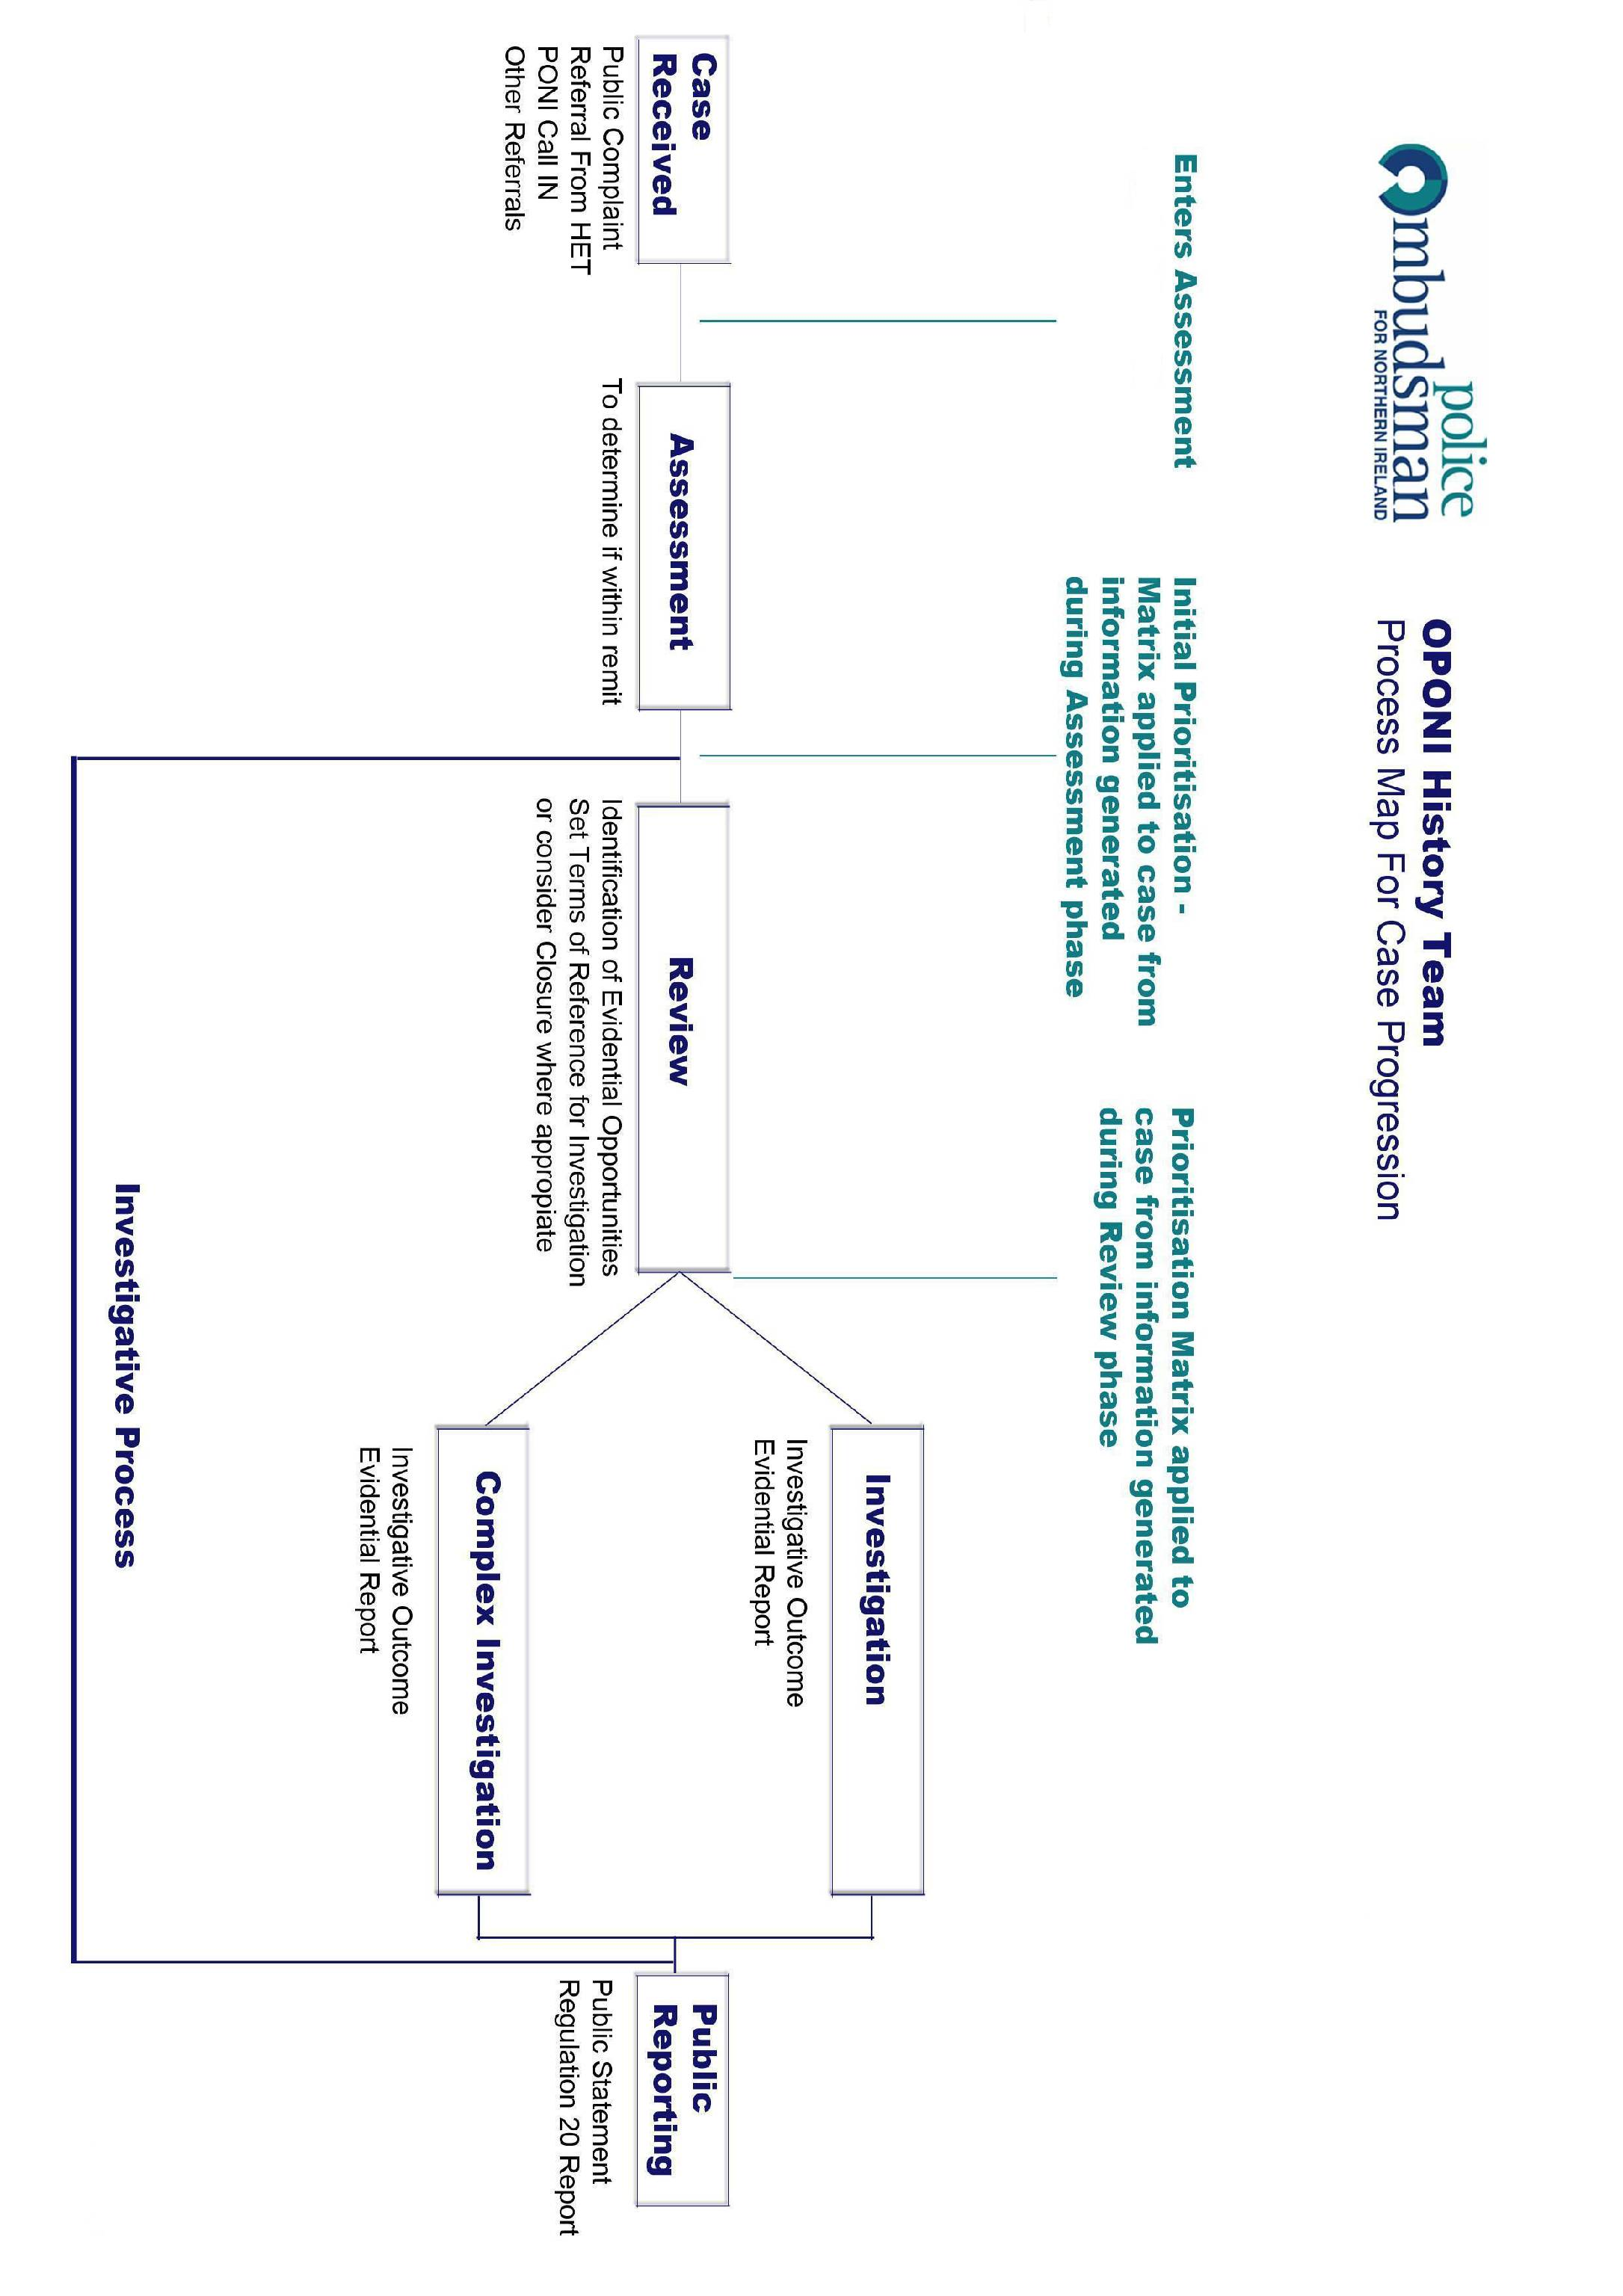

Appendix B

HISTORICAL INVESTIGATION PRIORITISATION MATRIX

Gravity of Specific Offences
High | 4 | 7 | 9
Medium | 2 | 5 | 8
Low | 1 | 3 | 6
 | Low | Medium | High
Nature of Conduct

Cases in which the alleged criminality may pose immediate danger to life, serious injury to a person, serious damage to property or loss of specific evidential opportunities, will be prioritised with an immediate investigative response.

All other cases will be subject to a four stage application of the prioritisation matrix.

Stage One - Gravity of Specific Offences

The cases are then marked against the gravity of the alleged offence by police officers within the table. As a guide:

- Criminal conspiracies & murder (High)
- Perjury, Perverting the Course of Public Justice (Medium)
- Gross misconduct & other criminality (Low)

Stage Two – Nature of Conduct

Cases are assessed into one of the following categories:

- Alleged criminality by serving officers involving two or more incidents (High)
- Deaths in which there is a direct causal link to police action, e.g. discharge of firearm (High)
- Alleged criminality by former police officers involving two or more incidents (Medium)
- Alleged criminality by serving police officers in relation to a single incident (Medium)
- Alleged gross misconduct by serving police officers (Low)
- Alleged criminality by former police officers in relation to a single incident (Low)
- Alleged misconduct by former police officers (No Score).

Stage Three

Two points will be added to cases in which there are pending criminal or inquest proceedings.

Stage Four

A qualitative statement may be obtained from complainants and/or their representatives. This is designed to capture such issues as age or infirmity of parents; partners or siblings of the deceased; additional factors such as proven associated miscarriages of justice; the length of time the complaint has been with the Police Ombudsman, and other matters the Complainant or the Police Ombudsman considers relevant.

These issues will serve to prioritise matters which attract the same marking after Stages 1, 2 & 3 and in exceptional circumstances will influence the overall marking and associated prioritisation of cases.

Appendix C

GUIDING PRINCIPLES FOR APPLICATION OF PRIORITISATION POLICY

- At Initial Prioritisation it is unlikely that information regarding the identities of police officers who may be subject of complaint will be available to the Police Ombudsman. Whether these are retired or former officers is, however, relevant to Initial Prioritisation. The process will therefore assume that all officers who may be potential suspects, served a standard thirty year police career and would not have been tasked with murder investigations until they had at least five years service. It follows, that as at 2012, a serving police officer could not have joined the RUC any earlier than 1982 and not been tasked with a murder investigation until 1987. For the purposes of Initial Prioritisation therefore, a complaint concerning the conduct of a murder investigation that occurred prior to 1987 will not involve currently serving potential suspects while a similar complaint in relation to an investigation that occurred in 1987 or later may involve police officers who are still serving.

- At the Assessment Phase, cases will be linked on the basis of either direct or implied allegations of links to other murders, by complainants or their representatives OR by information held by the Police Ombudsman that may suggest a potential link. The nature of any such links should be directly relevant to the remit of the Police Ombudsman. The involvement of a specific member of the public will not necessarily be a relevant matter.

- Cases that are linked at the Assessment Phase will be the subject of Initial Prioritisation and progression to the Review Phase as a potential linked group. The Review Phase will recommend links within Review Policy and identify whether potential suspect police officers are still serving. This information will support an informed, full prioritisation process at the conclusion of the Review.

Appendix D
The Investigative Process for the Police Ombudsman’s Historic Cases
The Pre-Investigation Process

Upon receipt of a new Public Complaint or Referral the matter is tabled as a ‘New Case’ at the Historic Directorate’s ‘Initial Prioritisation and Assessment Group’ (IPAG) by the Directorate’s Office Manager, for early consideration as to whether it is within the remit of the Police Ombudsman.

If, on the face of it, the matter is inside remit, the case is allocated to the Historic Investigations Communications Co-Ordinator for Assessment. This involves early engagement with the Complainant(s) and research of the matter, in order to recommend whether the case should be formally accepted for investigation. The case is then tabled at IPAG for a formal decision, on the basis of clarification of the complaints and research conducted, as to whether the case is inside remit.

Those cases that are determined to be inside remit are prioritised in accordance with the Police Ombudsman Historic Investigations Prioritisation Policy, previously subject of targeted public consultation, in order to establish the sequence in which the case will be investigated. Where cases are linked within ‘complex’ cases, the matters are prioritised in accordance with the individual case with the highest prioritisation marking.
The Investigation Process

Following the prioritisation process, Complainants and Interested Parties are advised of the likely timescale for commencement of the investigative process in relation to their case, currently either Phase 1 (to be commenced by 31 January 2015) or Phase 2 (to be completed by 31 March 2019), and communication contracts are agreed in order to keep them sighted on developments in their case. Communications through to commencement of investigations are conducted by Investigations Support (Communications Unit).

An intrinsic element of the investigation process is the initial review. This process launches extensive research, including identification of the whereabouts of relevant material, identifies whether the matter may be subject of provisional linking to other cases, and establishes the broad analytical and intelligence requirements of the case. This element of the investigative process is led by Investigations Support (Review Unit) and may result in early resolution of the matter or identify a requirement for re-prioritisation.

Matters progressing to full investigation are assigned terms of reference by the Director of Investigations (History), including target date for delivery of a complete investigation.

Investigation Teams, composed of a mixture of experienced staff recruited externally and internally from within the Office, are not allocated more than two to three investigations at any one time of which only one will be ‘complex’ in nature. This is to ensure focused and manageable Inquiries.

Each investigation produces a comprehensive CSR (Current Situation Report), clearly identifying both the accumulated findings of the Inquiry and investigative progress during the preceding month, to the monthly tactical Silver Group. The CSRs are considered by the Police Ombudsman, Chief Executive and Director of Investigations (History) and investigative developments/direction discussed at the Silver Meeting. Each version of the CSR is retained and notes recorded of the Silver Group Meetings.

The Police Ombudsman’s Gold Group, composed of the Police Ombudsman, Chief Executive, Senior Legal Adviser and both Directors of Investigations, consider and direct on overarching strategic issues emerging from investigations and the Silver Group.

As part of the Quality Assurance process, investigations are subject of documented reviews as follows:
  - 7 Day SIO self review
  - 28 Day Review by the internal Historic Investigations Review Team
  - 90 Day Review by the internal Historic Investigations Review Team
  - Reviews thereafter upon the direction of the Director of Investigations (History)

Requests for additional short term resourcing support from within the wider Historic Investigations Directorate are tabled by SIOs at the Directorate’s ‘Tasking & Co-Ordination’ Group attended by the Director of Investigations (History) and SIOs every two weeks. Notes of meetings are retained.

Where evidence indicates a crime may have been committed by a member of the RUC in relation to historic investigations, files are forwarded to the Public Prosecution Service who may also be consulted for ‘prosecutorial advice’.

Upon conclusion of an investigation a comprehensive ‘investigation report’ with supporting evidential material is submitted via the Director of Investigations (History) to the Chief Executive and Police Ombudsman. Should the Ombudsman or Chief Executive require clarification or additional enquiries the matter is referred back to the SIO responsible. When the Police Ombudsman is satisfied that all necessary enquiries, including examination of related intelligence dimensions, have been conducted, the investigation report is finalised and subject of ‘sign off’ by the Police Ombudsman.

The Public Reporting Process
Finalisation of the investigation report initiates compilation of associated public statements and other necessary statutory reports. This process adheres to the following pathway during which notes of meetings are recorded and retained:
  - During the investigation report ‘sign off’, attended by the Police Ombudsman, Chief Executive, Senior Legal Adviser, Director of Investigations (History), SIO responsible and Head of Investigation Support, the Ombudsman articulates his preliminary findings which will inform the public statement.
  - When the Police Ombudsman is satisfied that the draft public statement is representative of the investigation report and his determinations he directs initiation of a ‘Red Group’, composed of members of the organisation’s senior management team.
  - The Red Group receives the investigation report and draft public statement and meets to advise the Ombudsman as to whether the statement is representative of the evidence articulated in the investigation report and his findings are legally and otherwise sustainable. This may, on the direction of the Ombudsman, lead to further drafting of the public statement.
  - Supported by the Red Group, the Police Ombudsman reaches a determination on the final version of the draft public statement which is then shared with the PSNI, and any other agencies identified within the report, for ‘factual accuracy’ checks.
  - Upon receipt of ‘factual accuracy’ feedback from the PSNI and other agencies, the Police Ombudsman re-convenes his ‘Red Team’ to consider and direct on any further factual accuracy work he requires in relation to the public statement.
  - The public statement is finalised and interested parties notified of the schedule for publication.

Equipped with the final version of the public statement, the Director of Information, supported by the Red Group and SIO responsible, develops a finishing strategy for publication of the report, including final engagement with the Complainant(s) involved, media and other interested parties.

Paul Holmes
Director of Investigations (History)
1 July 2014
Historic Investigation Prioritisation Policy
Addendum

The purpose of this addendum is to record arrangements in respect of the application of the prioritisation policy that have previously been implemented in respect of ‘Complex’ cases.

The cumulative mark of all cases consolidated within a ‘complex’ investigation will be used during the application of the prioritisation policy.

For example:

Case A (3 marks) + Case B (9 marks) + Case C (0 marks) + Case D (5 marks) + Case E (3 marks) = 20 marks. Therefore the cumulative mark of 20 is used for the purposes of the prioritisation policy and therefore scheduling of the investigation.

In recognition that this is likely to result in the prioritisation of all ‘complex’ cases over standalone matters, and as outline in the Police Ombudsman’s historic investigations strategy, the active caseload will include both ‘Complex’ and ‘Other’ investigations i.e. either investigation teams will simultaneously have a caseload of both ‘Complex’ and ‘Other’ matters or at least one investigation team will be set aside for the investigation of ‘Other’ cases, subject to the availability of appropriate levels of funding/resources.

Paul Holmes
Director of Investigations (History)
10 September 2015

Historical Investigations Directorate
Police Ombudsman for Northern Ireland
New Cathedral Buildings
Writers’ Square
11 Church Street
Belfast
BT1 1PG

Telephone: 028 9082 8600
Fax: 028 9082 8659
Textphone: 028 9082 8756
Witness Appeal Line: 0800 0327 880
Email: info@policeombudsman.org

These publications and other information about the work of the Police Ombudsman for Northern Ireland are also available on the Internet at:

www.policeombudsman.org

