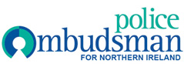

EQUALITY SCREENING REPORT

April 2014 – June 2014

Screening decision
1. | ‘Screened in’ with Equality Impact Assessment
2. | ‘Screened out’ with mitigation
3. | ‘Screened out’ without mitigation

Policy Title | Policy Aim | Screening decision
Smoke Free | To protect all employees, consultants, contractors, or visitors from exposure to second-hand smoke and to assist compliance with the Smoking [Northern Ireland] Order 2006. | ‘Screened out’ without mitigation.

