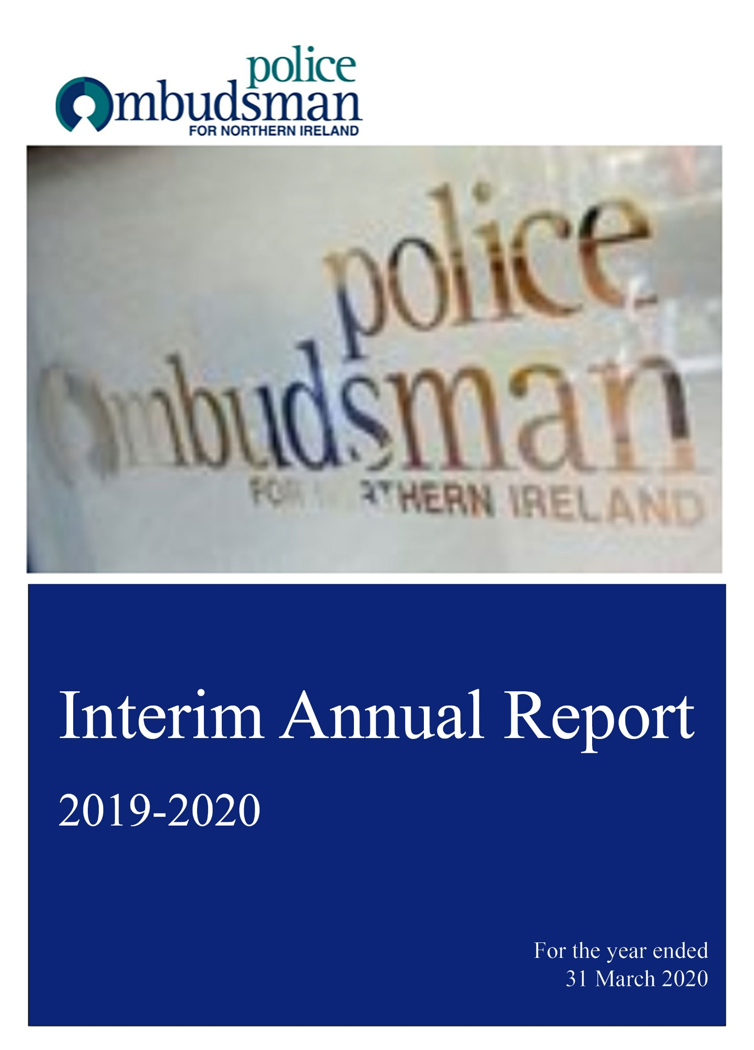

Annual Report Foreword by the Police Ombudsman

I am pleased to present to the Department of Justice my first Annual Report as Police Ombudsman for Northern Ireland, covering the work of my Office in the 2019/20 reporting year. I am required under s61(3) of the Police (Northern Ireland) Act 1998 as amended, to provide an Annual Report on the discharge of the Police Ombudsman’s functions by 30 June each year. However, as that business year drew to a close, the full extent of the worldwide public health pandemic became clear and my Office like all public and private life went into ‘lockdown’ lasting several months. While we maintained a limited police complaints service during this period, a lot of our supporting work had to be scaled back, including work on the year end Annual Report and Accounts.

Therefore, although this is a much abridged version of the normal Office Annual Report, I have sought to provide in summary form, information which both reflects the key aspects of our work during the period and allows an assessment of that work against our key objectives and targets. Further information will be published in the coming months, including a full Annual Report and Accounts in line with Department of Finance guidance in FD(DoF) 05/20.

Since becoming Police Ombudsman, I have been speaking to external stakeholders and to staff about the challenges of investigating complaints about police conduct. The Police (Northern Ireland) Act 1998 directs that I keep under review the efficiency and effectiveness of the police complaints system to ensure it continues to win the trust and confidence of the public and the police. I am committed to the principles and policies underpinning the original design of the police complaints system as designed by Dr Maurice Hayes and envisaged by the Patten Commission, including the model of a single portal for all complaints about police. This complaints system remains an important police accountability mechanism and has stood the test of time. Independent remains the cornerstone of this system to ensure public and police confidence in the Office.

In listening to stakeholders I believe that as we enter our twentieth anniversary year the focus for the work of the Office for the next three years must be towards increased transparency in decisions, fair procedures and processes and collaborative working with justice partners. These themes have formed the basis of my Strategic Plan for 2020/21 to 2023/24 and my Annual Business Plan 2020/21.

My Chief Executive in her Performance Report will provide in summary form information about the volume of work the Office has dealt with during the year in dealing with complaints and referrals about the conduct of police officers.

During the year I had to address a number of strategic issues connected to that work.

As the year came to an end my Office was continuing to work closely with the PSNI to develop a new agreement which will regulate the processes by which police provide information to this Office. Since my appointment I have wanted to develop the process to ensure my investigators have access to all police material. During the year I became directly involved in the issue of police disclosure of information which had been identified by my predecessor and got a detailed understanding of how PSNI searches its vast estate for material.

I consider that on occasions my investigators need to be directly involved at every stage of that search. I know that providing us with all requested information and documents has at times presented challenges for police, not least because of the vastness of the records management task. I am mindful also of the legal duty on both police and this Office to protect the most sensitive information. It is hoped the new agreement when completed will provide more effective searching for and sharing of this information. At the time of writing I believe that goal is within reach.

During the year the Office committed significant time and resources to ensure that we have the necessary structures in place to support the programme of inquests for ‘Troubles’ related deaths announced by the Lord Chief Justices. As my Office is involved with an inquest in each quarter of the first year of the programme, my Legal Director and her team have been involved in complex and time-consuming work. To support that work, I have decided to establish a ‘legacy disclosure unit’ and have made a bid to the Department of Justice for the necessary resources.

Time was also spent during the year putting in place some of the building blocks which will support my aim to ensure that as an ombudsman office all our practices meet modern Ombudsman standards. I have worked with our Current Investigations Directorate to put in place procedures aimed at bringing greater transparency around decisions in misconduct cases, including the provision by PSNI of cogent and full reasons when it does not accept my recommendations. With the Director, I have revised the processes for writing reports on those cases referred to us, largely by the PSNI, and deemed to be in the public interest. I hope these new processes will better explain in each of those cases our investigation process and decision making.

I believe that securing effective change in policing practices is an important aspect of holding police to account. This change can only be achieved when working with justice partners and during the year I have engaged with the Northern Ireland Policing Board to discuss ways of ensuring that police are held to account when recommendations are not accepted or fully implemented.
Finally, may I pay tribute to my Chief Executive and staff for their support in my taking up this challenging new role and for their continued patience with me. Dr Maguire has been a support to me in my new role and I thank him for that and his service to the Office over the last seven years.

MARIE ANDERSON
POLICE OMBUDSMAN FOR NORTHERN IRELAND

THE POLICE OMBUDSMAN FOR NORTHERN IRELAND
- was established by the Police (NI) Act 1998 and is:
- a corporation sole
- accountable to the Northern Ireland Assembly;
- constituted and operated independently of the Northern Ireland Policing Board (NIPB) and the Chief Constable;
- required to have regard to any guidance given by the Department of Justice (DoJ)
- and is an executive Non-Departmental Public Body financed by a Grant in Aid from the DoJ.

THE POLICE (NI) ACT 1998 (AS AMENDED) DIRECTS THE POLICE OMBUDSMAN TO:

- exercise his (her) powers in the way she (he) thinks best calculated to secure the efficiency, effectiveness and independence of the police complaints system and the confidence of the public and of members of the police force in that system;
- observe all requirements as to confidentiality;
- receive complaints and other referred matters and decide how to deal with them;
- investigate complaints, referred matters and matters ‘called in’ for investigation by the Police Ombudsman;
- receive and record policy complaints and refer them to the Chief Constable;
- make recommendations to the Director of Public Prosecutions for criminal prosecution;
- make recommendations and directions in respect of disciplinary action against police officers;
- notify the DoJ, NIPB and Chief Constable of the outcome of certain complaints, referred matters and any investigation which the Police Ombudsman initiates without a complaint;
- report to the DoJ annually;
- carry out enquiries as directed by the DoJ;
- supply statistical information to the NIPB and
- investigate a current practice or policy of the police if the practice or policy comes to his attention under the Act; and he (she) has reason to believe that it would be in the public interest to investigate the practice or policy.

Our Vision:

Our vision is to provide excellence in the independent and impartial investigation of police complaints, which builds confidence and improves policing for the community.

Our Values

We are:

Independent
- Our investigations and the work that supports them are evidence based and not influenced, controlled or subject to pressure from others.

Impartial
- We treat everyone with integrity and fairness and undertake our work without bias and free from preconceptions.

Accountable
- We do what we say, we accept responsibility for our actions and we recognise that we are accountable for our decisions

Respectful and Professional

- We treat everyone with respect through the quality of our work by being professional and by living our values every day.

Chief Executive Report /Performance Report

As Chief Executive, I am pleased to report on some aspects of the business and performance of the Office during the last year.

As Marie has noted, our end of year and period thereafter has been significantly impacted by the impact of the worldwide pandemic. It has been far from business as usual and one of the consequences has been that we are not yet in a position to make a full report on the activities of last year in the format which we normally produce. I would like to pay particular tribute at this stage to those colleagues who ensured that the police complaints system operated throughout the most difficult weeks and months during ‘lockdown.’ Like so many others in society, they proved that a commitment to the ethos of public service remains strong.

In this much shorter version of our Annual Report I have focused on the provision of that information which is available at this stage and which best illustrates the volume and complexity of the work we have undertaken, while allowing for an assessment of our performance against key objectives. This Report does not include the customary Accountability Report nor Financial Statement. A full Annual Report and Accounts will be completed in due course in line with Department of Finance guidance FD (DoF) 05/20.

The information currently available illustrates that it has been a busy year, both in terms of our normal case work and the broader strategic issues the Office has dealt with. Marie has brought with her a renewed focus on fairness, transparency and accountability.

The Office received 2,552 complaints during the year in question. This was a decrease of 5% from the previous year.

Criminal investigations were the most common situation which gave rise to complaints to the Office. More than two fifths of complaints were subject to a full investigation. In 13% of these, the Office found evidence to substantiate all or part of the complaint or identified another concern during the investigation. On 20 occasions during the year, we recommended that the Director of Public Prosecutions should prosecute an officer and we recommended on 152 occasions that a police officer should receive a discipline or a performance action.

While most of the complaints we receive are about current policing, the Office now has more than 430 complaints about matters connected to events which happened during ‘The Troubles.’ These cases, all of which are complex, are managed by our Historical Investigations Directorate. They are assessed using our ‘Grave and Exceptional’ policy, so as to prioritise them against available resources. Those resources are limited. The Directorate has 25 investigators and it is a challenging task to manage this relatively small investigation unit to deal with heavy workload. In light of this, a funding bid for additional resources was made in year to increase the staffing complement by 18.

The Office was not able to conclude or publish the findings of any of its historical investigations during the year in question. It was awaiting the outcome of a legal challenge to the Court of Appeal which questioned the powers of the Office in relation to such matters and also the power to make public statements generally. That judgment was provided in June 2020 and we are carefully considering its content.

Key Issues and Risks facing the Office

Within the executive processes of the Office, there is an embedded corporate approach to risk management. The risk register is reviewed by Senior Management on a regular basis making the risk register a dynamic document and is included as a standing item on all SMT agendas. Directors consider signs or warning of risks, examine existing controls to reduce or manage risks and if necessary take additional action.

In addition the Audit and Risk Committee consider the Risk Register at each quarterly meeting. Further information in relation to risk management is contained in the Governance Statement at pages 36 to 42

There are four key strategic risks facing the Office. These are:

- a risk that the budget allocated to the Office is insufficient for the Office to function effectively in the delivery of its statutory duties and that any further reduction would undermine the capability and capacity of the Office to undertake its statutory functions;
- a risk around the uncertainty surrounding the establishment of an Historic Investigations Unit (HIU) under the Stormont House Agreement which could lead to a number of issues including higher staff turnover in the History Directorate, uncertainty and reduced morale for those permanent staff currently working in the History Directorate and current lack of funding to progress Historic investigations in a timely manner, leading to legal challenge and reputational damage to the Office;
- a risk that information for sensitive cases may not be accessible such that the Office may fail to conduct an effective/complete investigation; and
- a risk that the Covid 19 outbreak may significantly affect operational activities and outcomes for a considerable period of time due to limitations on the ability of staff to work from home.

OLWEN LAIRD
CHIEF EXECUTIVE

Included below is a table providing in summary form the work the Office completed during the year in dealing with complaints about police.

Complaints Closed | 2,524
Complaints closed following initial assessment | 499
Complaint was not a matter for the Police Ombudsman | 309
Notifications from PSNI | 148
Other | 42
Complaints closed following initial enquiries | 775
Complainant did not fully engage with the police complaints system | 656
Ill-founded | 19
Withdrawn | 80
Other | 20
Complaints resolved informally | 191
Informally Resolved | 191
Complaints closed that relate to the ‘Troubles’ | 9
History Complaints | 9
Complaints fully investigated | 1,050
Complaint substantiated or an issue of concern identified | 136
Complaint not substantiated or no issue of concern identified | 914

Number of prosecution and no prosecution recommendations made by the Police Ombudsman for an officer/staff member to the PPS, 2019/20

 | 2019/20
Prosecution recommended for an officer/staff member | 20
Prosecution not recommended for an officer/staff member | 191

Number of recommendations made by the Police Ombudsman for an officer/staff member to receive a discipline or performance action, 2019/20

Regulations Introduced in June 2016[1] (Discipline or Performance Actions) | 152
Performance | 56
Misconduct Meeting | 88
Misconduct Hearing | 8

CONFIDENCE IN THE POLICE COMPLAINTS SYSTEM

Legislation requires the Police Ombudsman to provide a police complaints system in which the public and the police can have confidence.

For the police complaints system to work the public must be aware of it, have confidence in it and have at least a basic knowledge of how they go about making a complaint. We also believe that if people have accurate information about our work they will have confidence in the service we provide to the community.

For these reasons we commit resources each year to ensuring the public are informed about our work, either by using the traditional media or social media or by other forms of engagement, such as face to face meetings within the community. Each year we also seek to get an independent measurement of how successful we have been.

The Northern Ireland Life and Times Survey, which was carried out between September 2019 and February 2020, included five questions about the public’s attitude to the Police Ombudsman’s Office. The main outcomes were as follows:

86% | Of respondents had heard of the Police Ombudsman
88% | Of Respondents who had heard of the Police Ombudsman were aware he is independent of police.
85% | Of respondents who had heard of her were confident she deals with complaints in an impartial way.
86% | Of respondents who had heard of the Office believed they would be treated fairly if they made a complaint.
87% | Of respondents who had heard of the Office believed it helped police do a good job.

More detailed information on the survey results, including a breakdown of responses by gender, age group and religion is contained in the ‘Public Awareness of the Police Complaints System in Northern Ireland, 2019‘ document available on our website -www.policeombudsman.org.

A Selection of CASE STUDIES

During the year the Office regularly publishes brief, anonymised case studies which when taken together provide an illustration of some of the complaints we have received and how they have been dealt with. All these case studies are available on our website. Included below are a few examples of such cases.

POLICE WARNED ABOUT ‘POTENTIALLY FATAL’ RESTRAINT TECHNIQUES
In January 2020 the Police Ombudsman warned police officers that certain restraint techniques could interfere with people’s ability to breathe, with potentially fatal consequences.
Mrs Marie Anderson urged police officers to ensure that people being restrained, especially face down, were not having difficulty breathing.

She made the appeal after an investigation found that a man had appeared to “pass out” while being taken into police custody after being arrested in September 2018. He was lying across the back seat of a police car when the incident happened, having been cuffed behind his back and had leg restraints fitted.
He was heard on police body-worn video telling officers that he could not breathe, before making gurgling noises and becoming quiet and motionless. Officers then stopped the car and revived him.
Mrs Anderson said the incident illustrated the potentially fatal risks associated with “positional asphyxia” which causes people to have difficulty breathing. A face down position is recognised as a risk factor, as are alcohol or drugs.
She urged officers to refresh their knowledge of police training and guidance on the issue provided on the PSNI website.
After concluding that the officer who had been with the man in the rear of the police car should have been more alert to the risks and danger signs of positional asphyxia, the Police Ombudsman recommended that he be disciplined.
The PSNI accepted that there had been failings and the officer in question was given advice and feedback by his line management.

OFFICERS DISCIPLINED AFTER COLLAPSE OF CRASH COURT CASE
Two police officers were disciplined over failings in the investigation of a head-on collision which had a “negative impact” on a subsequent court case.
A driver who suffered a broken wrist and ankle in the crash made a complaint after the other driver was acquitted of causing grievous bodily injury by careless driving. The complainant said it had become clear during the court hearing that the investigating police officer had failed to carry out a number of “fundamental investigative actions”.
She also alleged that the officer’s manager had not properly supervised the case, and had limited relevant experience at the time.
Our enquiries showed that the investigating officer had failed to take any measurements or to note the position of the cars or the condition of the road surface at the collision scene. She also failed to take usable photographs or to check either car for mechanical malfunction.
In addition, the police officer did not check whether either driver had been using their phones immediately prior to the crash. Further, she did not interview the suspect driver under caution and failed to take a statement from a witness until 10 months after the collision, by which stage his recollection was unclear.
We concluded that the police investigation had not been conducted “in a prompt, thorough, impartial and careful manner” and this had impacted negatively on the court proceedings.
Further, the officer’s line manager was found not to have provided her with appropriate support and professional guidance.
The PSNI subsequently implemented a Police Ombudsman recommendation that both officers should be disciplined.

USE OF INCAPACITANT SPRAY, TASERS AND IMPACT ROUNDS JUSTIFIED TO PREVENT WOMAN SELF-HARMING
A Police Ombudsman investigation concluded that police were justified in using incapacitant spray, TASERs and impact rounds to prevent a woman harming herself with a knife in east Belfast in November 2018.
Police had responded to a call from a member of the public who had seen the woman walking near train lines.
Officers went to the scene and tried speaking to the woman but received no response. When they noticed she had a knife, armed officers were tasked to help deal with the situation.
By the time they arrived, the woman had crouched down against a wall with her head bowed and the knife held to her throat. Rail traffic in the area was suspended and trained police negotiators spent two hours talking to the woman, who did not respond and continued to hold the knife to her throat.
Officers said they grew increasingly concerned for the woman’s welfare as she was not reacting to changing weather conditions and it was hard to tell whether she was still breathing.
Police used graduated levels of force in a bid to cause her to drop the knife, including two discharges of incapacitant spray, then two discharges of TASER, followed by the use of an AEP (Attenuated Energy Projectile) impact round. None of these produced any apparent response.

However, after being struck by a second AEP, the woman opened her hand and dropped the knife. Police officers provided immediate aftercare before ambulance staff took over and took the woman to hospital.

The Police Ombudsman, Marie Anderson, concluded that police had used graduated force with the aim of protecting life, and found their actions to have been reasonable and proportionate.

OFFICER DID NOT RACIALLY DISCRIMINATE AGAINST TAXI DRIVER

A press release was published in February 2020 which reported that a police officer had been cleared of racial discrimination against a taxi driver following an incident in south Belfast.
The complaint related to the taxi driver’s allegation that a customer had attacked him and damaged his glasses after refusing to pay. However, the customer claimed the taxi driver had assaulted him after refusing to pull over when he complained that the car was being driven too fast.
The taxi driver complained that the investigating police officer had refused to investigate his allegation but had pursued the customer’s report about him. He said the police officer had offered the customer a Community Resolution Notice (CRN) - a measure designed for low- level offending - which was inappropriate as he had suffered injury and his property had been damaged.
Enquiries showed that the driver and customer had both initially agreed on the use of a CRN. The agreement was cancelled, however, when both parties subsequently made formal allegations of assault.
The officer then investigated the allegations made by both parties. We concluded that the investigation had been “effective and timely”, and that the police officer had treated both parties fairly.

POLICE OFFICER BREACHED GUIDELINES BY FAILING TO INFORM SOLICITOR ABOUT VIDEO RECORDING

In February 2020, we reported that a police officer had breached guidelines by failing to advise a solicitor that she was recording Body Worn Video (BWV) footage in his office. The solicitor described the incident as a “breakdown of trust and courtesy”.

It happened when the police officer was handing over a sum of cash for one of the solicitor’s clients.

The officer said she recorded the exchange in order to protect both herself and the solicitor in light of a previous allegation made by the client. The solicitor said the officer should have sought his consent to being filmed, and said that if she had he would have refused.
BWV footage showed that the officer started recording before entering the solicitor’s office but only informed him after he noticed a red light flashing on the camera.
The officer accepted that she had breached police guidelines by failing to inform him, but said it had slipped her mind. She added that no one had viewed the footage before it was provided to the Police investigator. The Police Ombudsman, Marie Anderson, noted that the recording took place within an area where a high degree of privacy and confidentiality is expected. She said: “Police guidelines state that the use of body worn video should be overt, and subjects should be advised that audio and video is being recorded.”
She recommended that the officer should be disciplined. The PSNI decided to address the issue by implementing measures to improve the officer’s performance.

