

Public awareness of the system for complaints against the police in Northern Ireland, 2006

Policy and Practice Directorate

Office of the Police Ombudsman for Northern Ireland

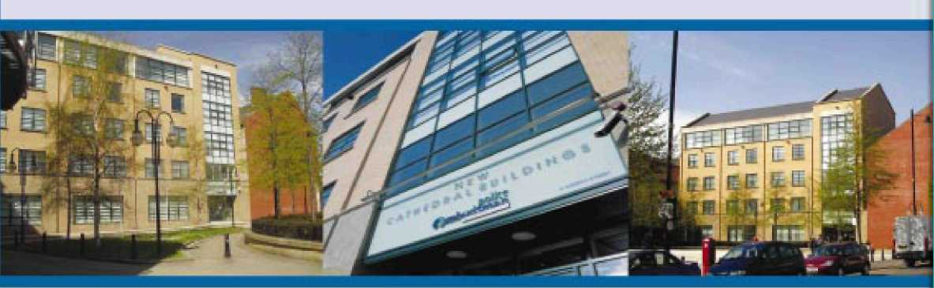

Contents

Page

Executive Summary 3

1 Introduction 5

2 Methodology 6

3 Survey Results 7

Perceptions of police misconduct 7 Making complaints against the police 9

Awareness of the Police Ombudsman 10 Impartiality of Investigation 14 Fairness and equality of treatment of complainant and police officers 15

Effect of Police Ombudsman on policing 17

Appendix 1: Survey Questions 20

executive Summary

Perceptions of police misconduct

Over four-fifths (85%) of survey respondents had never experienced unacceptable behaviour from a police officer; 9% said that they had experienced it once or twice and 4% said that they had experienced it more frequently. These findings are similar to those from previous surveys.

Sixteen percent of Catholics and 14% of Protestants said that they had experienced unacceptable behaviour. The most frequently reported type of unacceptable behaviour was that a police officer had been disrespectful or impolite.

Making complaints against the police

Some 22% of those respondents who had experienced unacceptable behaviour said that they had complained about the incident. The most frequent reasons given by those who had not complained were firstly a belief that nothing would be done about their complaint and secondly a belief that the incident would not be taken seriously.

Just over half of all respondents (53%) said that they would go first of all to a police station in order to make a complaint against the police; 14% said that they would go to a solicitor and 9% said that they would go to the Police Ombudsman.

A larger proportion of Protestants than of Catholics said that they would go to a police station, while Catholics were twice as likely as Protestants were to say that they would go to a solicitor. Protestant respondents (10%) were more likely than Catholics were (7%) to say that they would go to the Police Ombudsman.

Awareness of the Police Ombudsman

Eighty four percent of respondents said that they had heard of the Police Ombudsman, a similar proportion to those in previous surveys. Protestants (85%) were marginally more likely than were Catholics (81%) to be aware of the Police Ombudsman, while respondents aged under 25 showed lower levels of awareness of the Police Ombudsman than older age groups. The source of information about the Police Ombudsman most frequently cited by respondents was television (90%).

The majority (84%) of those respondents who had heard of the Police Ombudsman thought that she was independent of the police; this figure has varied only slightly since October 2000. Eleven percent of respondents thought that the Police Ombudsman was part of the police. Protestants and Catholics had similar levels of awareness of the Police Ombudsman’s independence.

Impartiality of Investigation

Just over three-quarters (76%) of respondents were confident that the Police Ombudsman deals with complaints in an impartial way, up from 61% in 2002; 17% were not confident that investigations were impartial. Seventy three percent of Catholics and 78% of Protestants were confident that the Police Ombudsman deals with complaints impartially; the latter figure has risen from 51% in 2002.

Fairness and equality of treatment of complainants and police officers

More than four-fifths (84%) of respondents thought that they would be fairly treated if they were to make a complaint against a police officer to the Police Ombudsman. There is a small difference in the proportions of Catholics (81%) and Protestants (86%) who thought that they would be fairly treated.

Almost nine out of ten respondents (89%) felt that a police officer being complained about would be treated fairly. Catholics responded more positively than Protestants when asked about the treatment of police officers, with 92% of Catholic respondents thinking that police officers would be treated fairly compared to 86% of Protestant respondents.

Those respondents who said that they thought that either the complainant or the police officer would not be treated fairly were asked which party they thought the complainant treated better. Around a third (34%) said that they thought the complainant was treated better, while more (58%) said that they thought the police officer was treated better. Catholic respondents were more likely than Protestants to think that the police officer would receive better treatment and Protestants were more likely than Catholics to think that the complainant would be treated better.

Effect of Police Ombudsman on policing

More than four fifths of respondents (83%) felt that the Police Ombudsman would help ensure that the police in Northern Ireland do a good job. The proportion of Protestant respondents (83%) who believed that the Police Ombudsman will help ensure that the police do a good job has steadily increased since February 2002 and has now reached almost the same level as the proportion of Catholic respondents (84%).

The main reasons given by respondents were:
- The police would treat the communities in Northern Ireland more impartially;
- The police would give less cause for complaints from the public; and
- The police would investigate crime better.

- Introduction

The Office of the Police Ombudsman for Northern Ireland was established by the Police (Northern Ireland) Act 1998 to provide an independent system for investigating complaints against the police in Northern Ireland.

The Police Ombudsman’s Office is committed to carrying out research and consultation in order to improve the quality and effectiveness of the police complaints system. It is also committed to both informing the public about the Police Ombudsman’s powers of independent investigation and gaining the confidence of both the public and the police in the police complaints system and processes. As part of a programme of research, the Office carried out its first survey of public awareness of the police complaints system in October 2000. This was followed by surveys in March 2001, March 2002, February 2003, January 2004 and March 2005.

This report presents the findings from the seventh survey, which was carried out in January 2006. The data were collected through a module in the Northern Ireland Statistics & Research Agency’s (NISRA) Omnibus Survey.

The research provides information on:

- Experiences of police misconduct
- Awareness and independence of the Police Ombudsman
- Perceptions of the impartiality of investigation of complaints by the Police Ombudsman
- Perceptions of fairness and equality of treatment of the public and police by the Police Ombudsman
- Perceptions of improvements in policing due to the existence of the Police Ombudsman’s Office.

- Methodology

Fifteen questions were commissioned by the Police Ombudsman's Office for inclusion in the March 2005 NISRA Omnibus Survey.

The survey sample was drawn from the Valuation and Lands Agency list of addresses. This list was stratified into three regions (Belfast, East Northern Ireland and West Northern Ireland), and a random sample was drawn from each stratum. Interviewers called at each address on the list and randomly selected one person aged 16 or over living at the address for interview.

The total sample size was 2,200 addresses. The fieldwork took place between 16 January and 17 February 2006. Interviews were achieved with 1,122 individuals, representing a response rate of 57% of the eligible sample.

Weighting factors were applied to the data in relation to household size.

The percentages given in the tables have been rounded to the nearest whole number. The following symbols have been used:

  - 0%: figure in cell is less than 0.5%
  - - : cell is empty.
- Survey Results

Perceptions of police misconduct

When asked “Has a police officer ever behaved towards you in a way that you thought was unacceptable?” the majority of respondents (85%) said no, 11% said they had been treated unacceptably once or twice, and 4% had been treated unacceptably on more than 2 occasions.

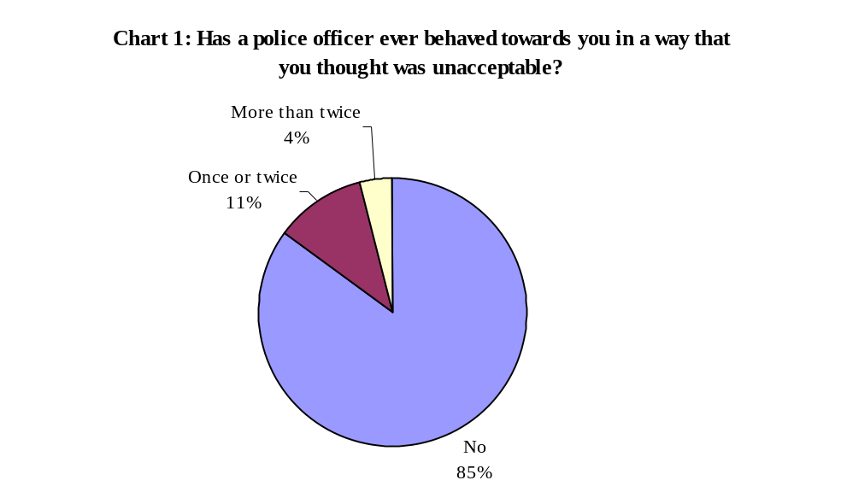

When comparing these findings to those in the previous year a marginal deterioration can be seen, as illustrated in Chart 2 below.

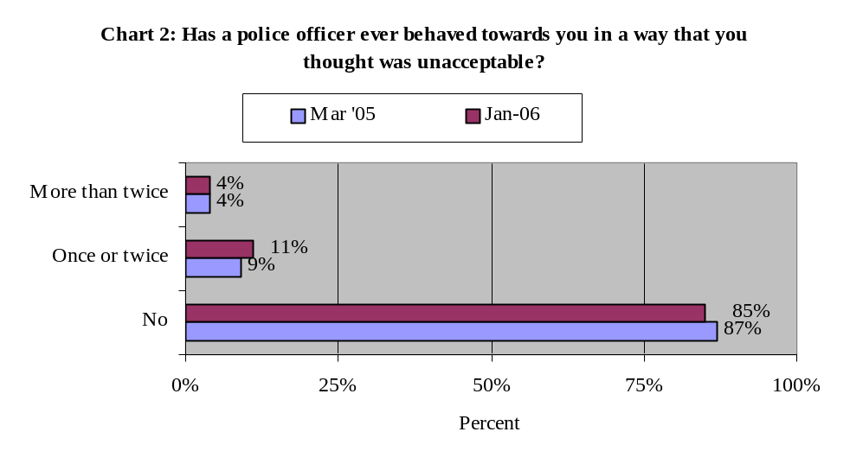

There is little difference between Catholic and Protestant respondents in relation to whether or not they had experienced unacceptable behaviour; 16% of Catholics compared to 14% of Protestants.

There was a more marked difference in the experiences of males and females, with 21% of males stating that they had been treated unacceptably on at least one occasion, compared to 10% of females.

Respondents aged over 65 were less likely than respondents in other age groups to say that they had experienced unacceptable treatment.

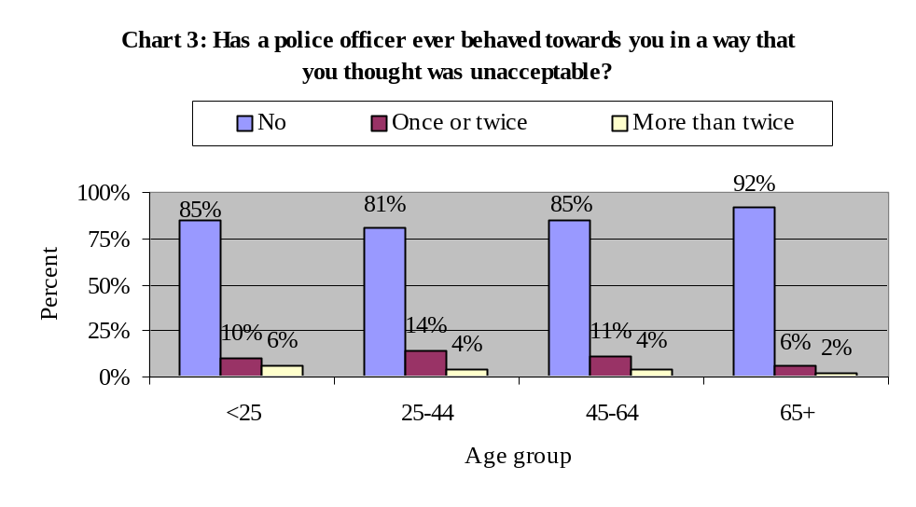
Those respondents who stated that they had been treated unacceptably by a police officer were asked to elaborate further; to describe the way in which the officer had behaved; whether or not they had complained about the incident; and, if they hadn’t complained, why they hadn’t.

When asked what the officer did that they felt was unacceptable, the most common response was that the officer was disrespectful or impolite to the respondent (67%). The next most common response was that the officer did not do his/her duty properly (20%) or did not follow proper procedures (20%).

Table 1 below shows a full breakdown of the types of unacceptable behaviour reported by respondents.

Table 1: Types of unacceptable behaviour

Behaviour | Percentage
Officer was disrespectful or impolite | 67%
Officer didn’t follow proper procedures | 20%
Officer did not carry out their duty properly | 20%
Harassment | 18%
Wrongly accused of behaviour | 18%
Officer was violent | 15%
Officer swore | 14%
Discrimination by race, gender, age or religion | 11%
Stopped or searched without reason | 9%
Officer used sectarian, racist or sexist language | 8%
Other | 6%
Searched house without reason | 5%
Officer took an item of respondent’s property | 3%
(Note: Percentages add to more than 100% as respondents could give more than one response)

Making complaints against the police

Of those respondents who had stated that they were treated in an unacceptable manner, 22% said that they had made a complaint about the incident.

Respondents who did not complain about their experience were asked why they didn’t make a complaint. The main reason quoted was a belief that nothing would be done about their complaint (32%), followed by a belief that it would not be taken seriously (23%). Only 1% of respondents said that they didn’t make a complaint because they didn’t know how (Table 2).

Table 2: Main reason why incident was not complained about

Reason | Percentage
Felt nothing would be done about the complaint | 32%
Felt it would not be taken seriously | 23%
Incident was not serious enough | 20%
Could not be bothered complaining | 10%
Scared of police reprisals | 6%
Didn’t want to make trouble for the police | 2%
Didn’t know how to complain | 1%
Forgot | 1%
Other | 4%

All respondents were asked where they would go initially to make a complaint against the police. Table 3 shows that respondents were most likely to make their complaint at their local police station (53%). Nine percent of respondents would take their complaint directly to the Police Ombudsman.

Table 3: Where respondents would go to initially to make a complaint

Where respondents would go to complain | Percentage
Local police station | 53%
Solicitor | 14%
Police Ombudsman | 9%
The Citizens Advice Bureau | 6%
Your MP/MLA | 5%
A local politician, e.g. a councillor | 3%
Chief Constable of the PSNI | 1%
The Policing Board | 1%
Other | 1%
Don’t know | 2%
Wouldn’t make a complaint | 4%

A larger percentage of Protestants (60%) than Catholics (43%) said that they would make their complaint at their local police station. Protestant respondents were also slightly more likely to go to the Police Ombudsman to make their complaint (10% of Protestants compared to 7% of Catholics). Catholic respondents (20%) were twice as likely as Protestants (10%) to make their complaint to a solicitor. Catholic respondents were also more likely to say that they would go to their MP or MLA (7%, compared to 3% of Protestants) or to a local politician (6%, compared to 1% of Protestants).

Awareness of the Police Ombudsman

Despite only 9% of respondents saying that they would initially go to the Police Ombudsman to make a complaint against the police, some 84% of respondents stated that they had heard of the Police Ombudsman for Northern Ireland. This is similar to the levels reported in previous surveys, and would suggest that the maximum level of public awareness has been achieved.

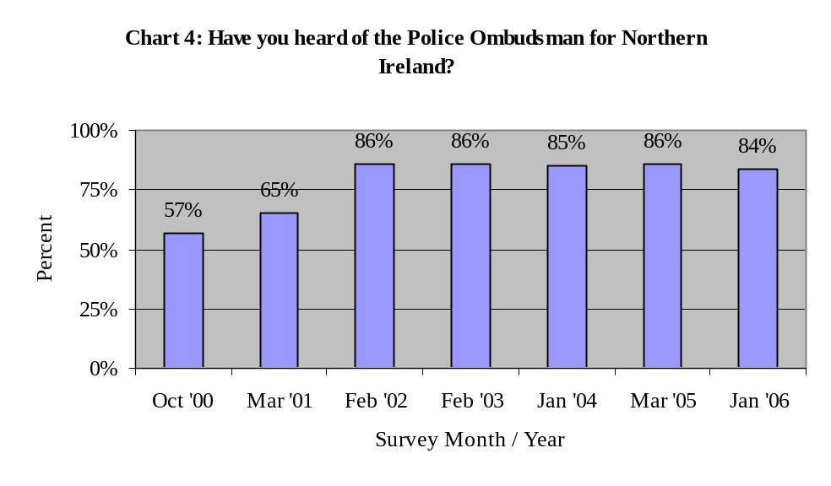
Generally speaking males (86%) are slightly more likely to have heard of the Police Ombudsman than females (82%) and Protestants (85%) are more likely to have heard of the Police Ombudsman than Catholics (81%). These results are similar to those evidenced in the last few years.

Awareness of the Police Ombudsman is greatest amongst the 45 to 64 age range (91%). Those aged under 25 continue to exhibit lower levels of awareness, with fewer than 3 in 5 (59%) respondents being aware. The awareness level in this age range has stabilised after declining steadily over previous years (Chart 5).

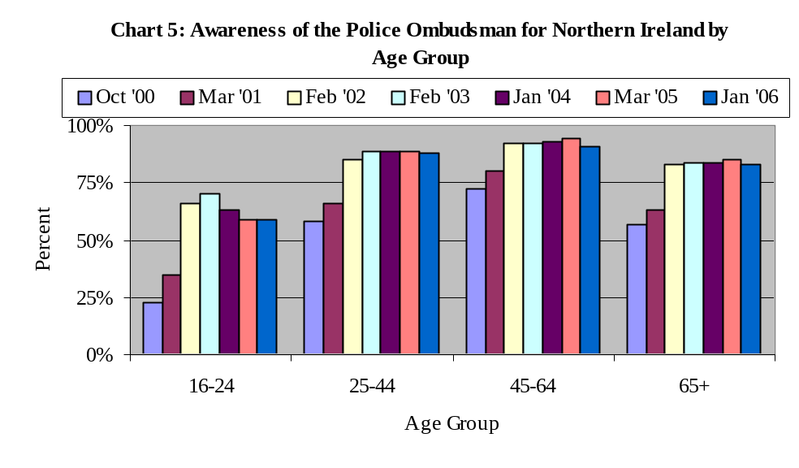
Awareness of the Police Ombudsman also varied according to the respondents’ level of educational attainment, with higher levels of educational attainment being associated with higher levels of awareness (see Chart 6).

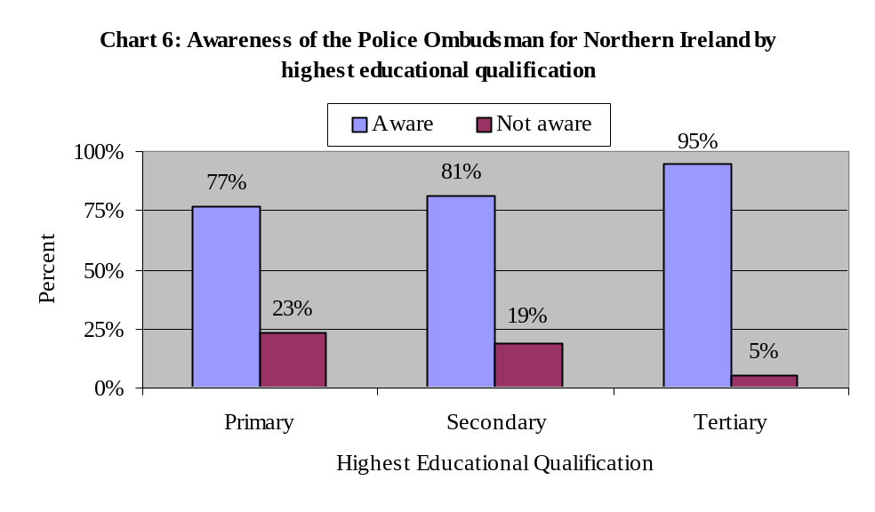
When asked how they had heard about the Police Ombudsman, nine out of ten respondents (90%) cited television. This echoed previous findings on the source of people’s awareness, with other media appearing at similar levels to previous surveys.

Table 4: Source of knowledge of the Police Ombudsman

Source of information | Survey Month / Year
Source of information | Oct ‘00 | Mar ‘01 | Feb ‘02 | Jan ‘04 | Mar ‘05 | Jan ‘06
Television | 74% | 82% | 91% | 93% | 89% | 90%
Newspaper/magazine | 35% | 49% | 49% | 56% | 43% | 49%
Radio | 23% | 31% | 39% | 44% | 31% | 40%
Word of mouth | 8% | 8% | 10% | 13% | 9% | 12%
Friends/family | 4% | 6% | 8% | 9% | 4% | 7%
Through work | -* | 6% | 6% | 7% | 5% | 7%
Leaflet | 3% | 1% | 4% | 6% | 4% | 7%
Poster | 1% | 1% | 2% | 4% | 2% | 3%
Internet | -* | -* | -* | 1% | 1% | 3%
Attended presentation | -* | -* | -* | 1% | 1% | 1%
Other | 3% | 1% | 1% | 1% | 1% | 2%
(Note: Percentages add to more than 100% as respondents could give more than one response)

All those respondents who had heard of the Police Ombudsman were asked for their opinion on whether or not the Police Ombudsman was independent of the police or part of the police. The majority of these respondents (84%) felt that the Police Ombudsman was independent of the police, with only 11% believing that she was part of the police. The results over time have remained fairly stable, suggesting that the maximum capacity on the awareness of the Police Ombudsman’s independence has been achieved (Chart 7).

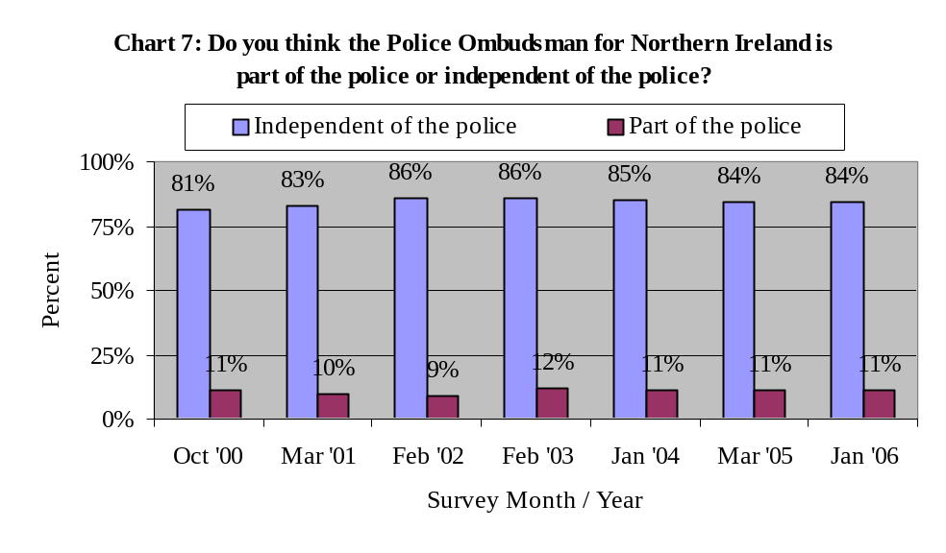
The past three surveys have shown smaller differences between the Protestant and Catholic communities in the awareness of the Police Ombudsman’s independence than the previous surveys, when the Protestant community appeared to be more aware (Chart 8).

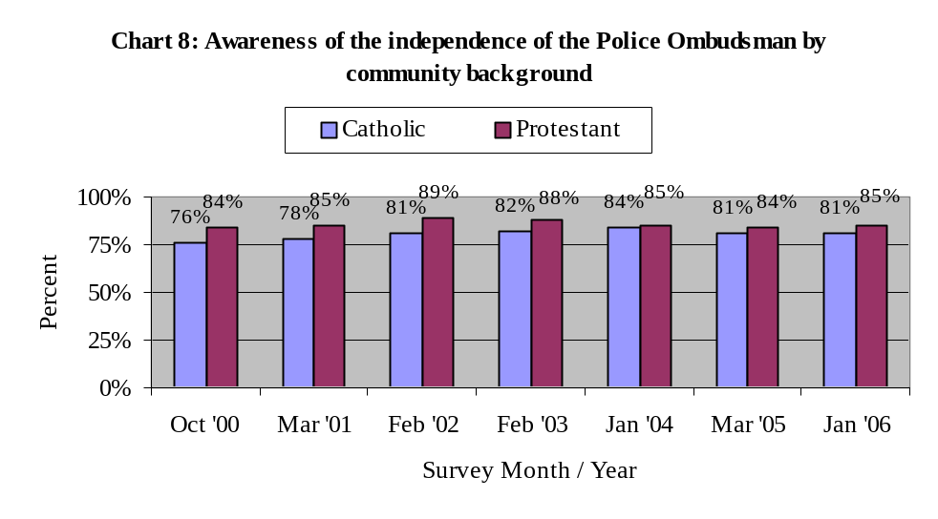
Respondents aged between 45 and 64 displayed the highest level of awareness of the Police Ombudsman’s independence from the police (87%), while the under 25s showed the lowest level of awareness (74%).

Table 5: Awareness of the independence of the Police Ombudsman by age group

Independence of the Police Ombudsman | Age Group
Independence of the Police Ombudsman | 16 – 24 | 25 – 44 | 45 – 64 | 65+
Part of the police | 23% | 10% | 8% | 9%
Independent of the police | 74% | 86% | 87% | 80%
Don’t know | 3% | 4% | 5% | 11%

Respondents who had heard of the Police Ombudsman were asked where they would go to find contact details for the Office in the event of them needing to make contact. Just over half (51%) would go to the telephone directory. Just under a fifth (18%) would go to a police station and the same proportion would use the Internet (Table 6).

Table 6: Source of information for contacting the Police Ombudsman’s Office

Where one would go to find contact details for the Police Ombudsman
Telephone directory | 51%
Internet | 18%
Police station | 18%
Directory enquiries | 7%
Advice agency | 5%
Political representative | 4%
Legal representative | 4%
Call at office | 3%
Community association | 1%
Other | 3%
Don’t know | 8%

Impartiality of Investigation

More than three quarters of those respondents who had heard of the Police Ombudsman (76%) were fairly confident or very confident that the Police Ombudsman deals with complaints in an impartial way. Seventeen percent were not very confident or not at all confident of the Police Ombudsman’s impartiality in investigations. Chart 9 below shows that confidence in the impartiality of the Police Ombudsman has increased markedly since February 2002, but that the trend has also slowed down significantly.

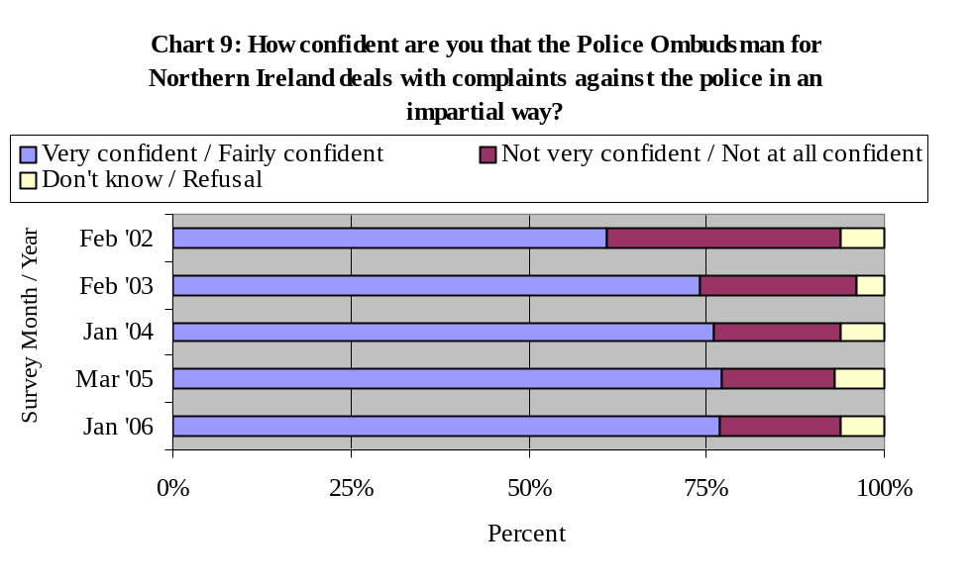
There is a difference in the levels of confidence in impartiality between the two main religious communities in Northern Ireland. Seventy three percent of Catholics and 78% of Protestants surveyed are confident that investigations are dealt with in an impartial manner. These findings reverse the trend that has been apparent in previous years where the level of confidence in impartiality was higher amongst Catholic respondents. The level of confidence amongst Protestant respondents has continued to increase whilst Catholic confidence has fallen over the last several years (Chart 10).

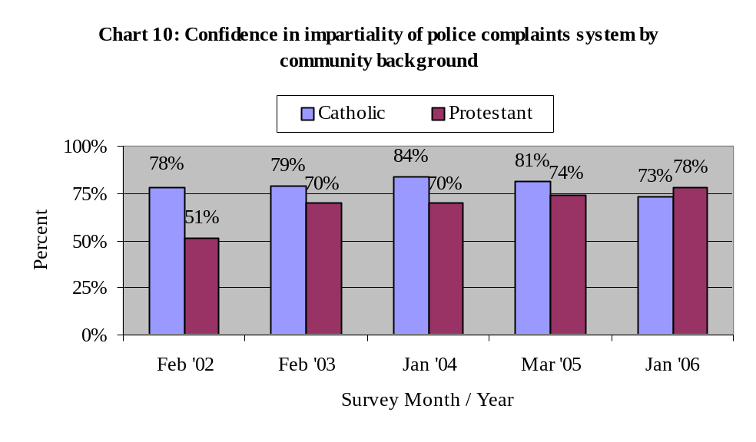
Fairness and equality of treatment of complainant and police officers

Respondents were asked how they felt complainants and police officers would be treated by the Police Ombudsman in the event of a complaint being made. Eighty-four percent of respondents stated that they thought that they would be treated fairly if they made a complaint against a police officer. This figure increased marginally between 2002 and 2006 (as illustrated in Chart 11 below).

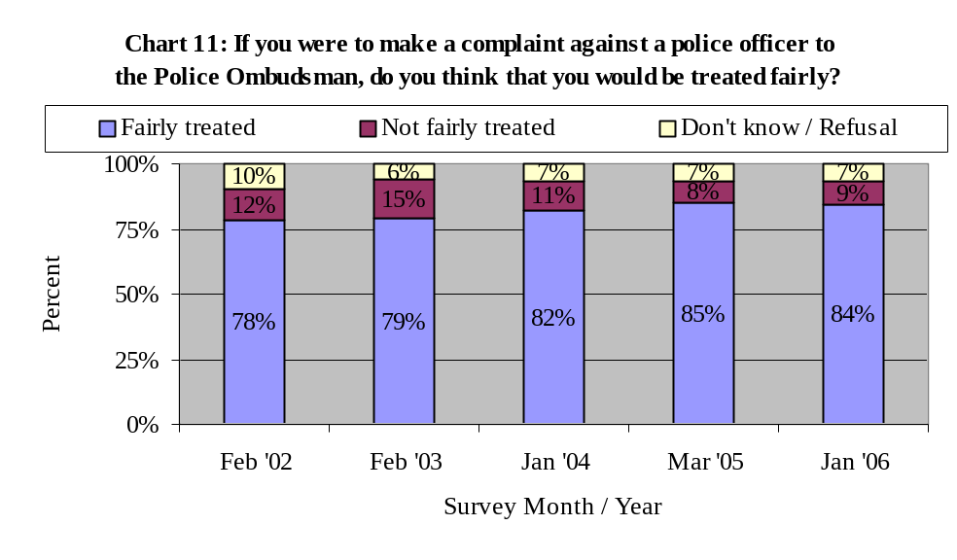
Further analysis of responses to this question shows that there is little difference between Catholic and Protestant respondents in relation to how they felt they would be treated if they made a complaint.

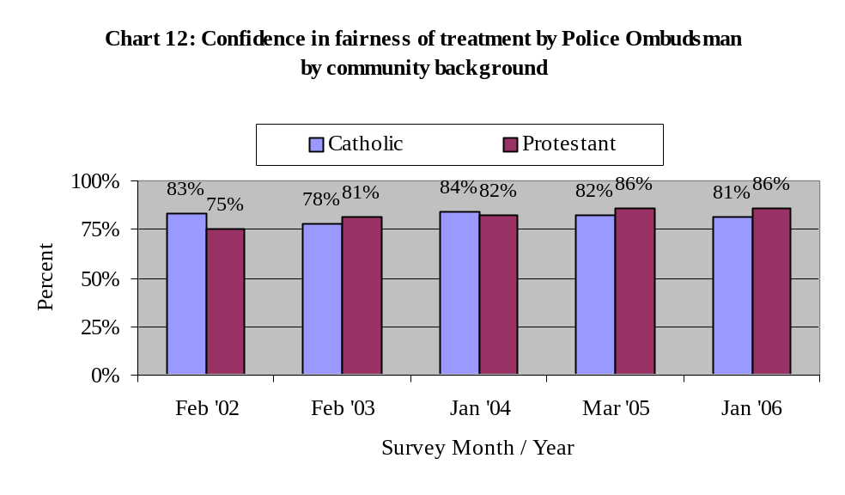
Similar results were found when respondents were asked for their views on whether or not police officers would be treated fairly by the Police Ombudsman in the event of a complaint being made against them. Almost nine out of ten (89%) felt that police officers would be treated fairly. The difference between the two main religious communities was slightly more marked than the difference between the two communities in relation to whether or not the complainant would be treated fairly, with 92% of Catholic respondents and 86% of Protestant respondents stating that they felt the police officer being complained about would be treated fairly.

Those respondents who felt that either the complainant or the police officer would not be treated fairly by the Police Ombudsman, were subsequently asked who they felt would be treated better; the complainant or the police officer.

Over a third (34%) of respondents believed that the complainant would be treated better, while 58% felt that the police officer would be treated better. These findings reverse the trend of the previous three years, which saw the proportion of respondents who thought that the complainant would be treated better rising and the proportion thinking that the police officer would be treated better declining (Chart 13).
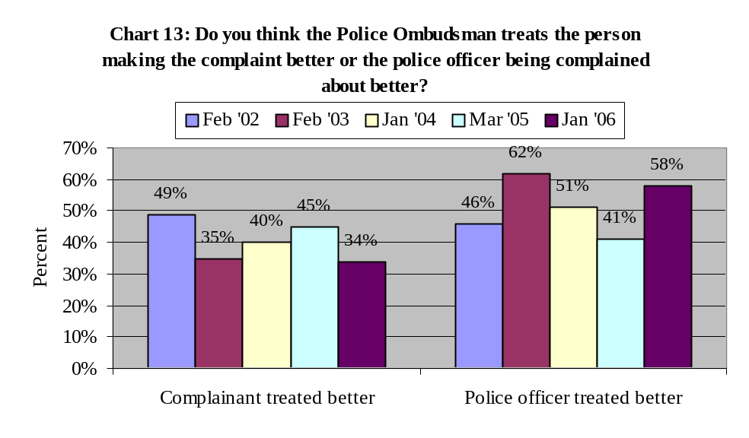
However, a high level of polarisation was found to exist between the two main religious communities in relation to who would be treated better by the Police Ombudsman. Protestant respondents (45%) were more likely than Catholics (17%) to feel that the complainant would be treated better than the police officer in question, while the opposite was true for Catholic respondents, with 77% believing that the police officer would be treated better, compared to 42% of Protestants.

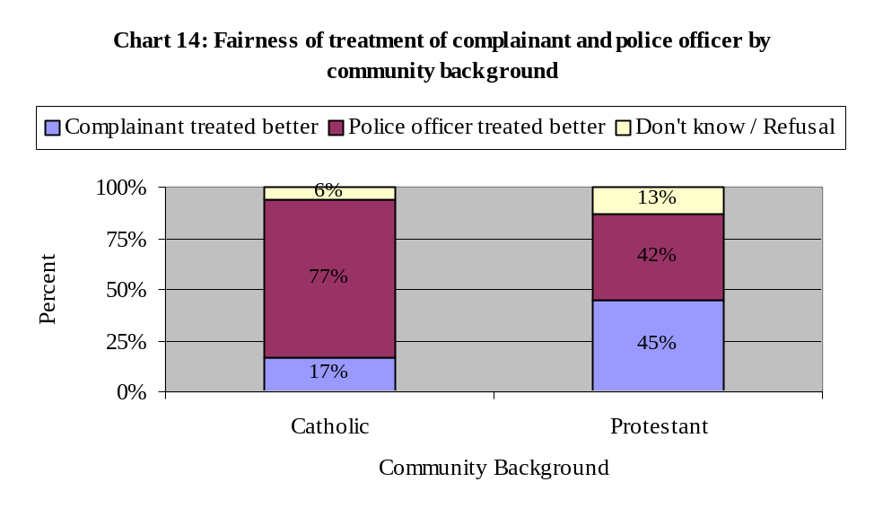
The trend evidenced by the results is similar in nature to those seen in previous years, although the magnitude of the differential has changed over the years. However, these findings should be treated with some caution, as the respondent base is quite small (Chart 15).
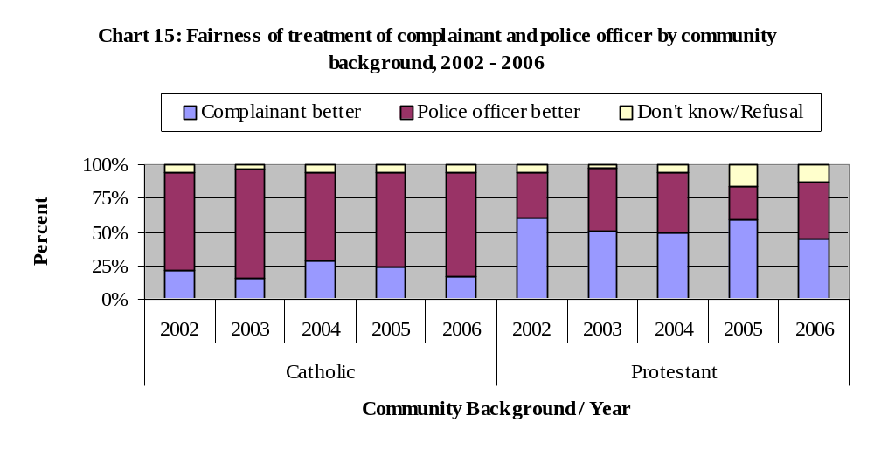
Effect of Police Ombudsman on policing

The final line of questioning undertaken was on whether the Police Ombudsman would contribute to effective policing in Northern Ireland and what aspects of the police would be improved due to the impact of the Police Ombudsman.

Overall, more than four fifths of respondents (83%) felt that the Police Ombudsman would help ensure that the police in Northern Ireland will do a good job (compared to 78% in 2005), and 10% said that the Police Ombudsman would not help policing in Northern Ireland.

The proportion of Protestant respondents (83%) who believed that the Police Ombudsman will help ensure that the police do a good job has steadily increased since February 2002 and has now reached almost the same level as the proportion of Catholic respondents (84%) (as seen in Chart 16).
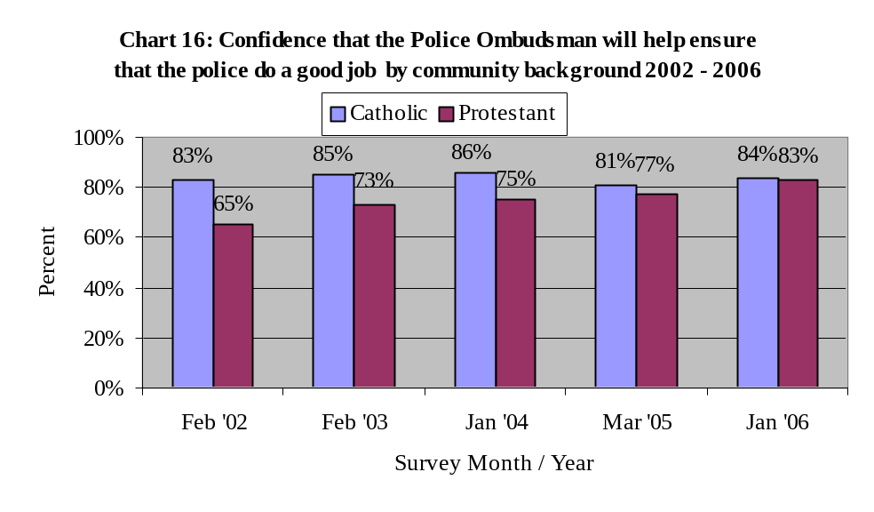
Those respondents who stated that they thought that the Police Ombudsman would help ensure that the police do a good job, were asked in what way they felt the police would do a better job. The three main reasons quoted were:

- The police will treat all communities in Northern Ireland more impartially (56%)
- The police will give less cause for complaints from the public (45%)
- The police will investigate crime better (27%)

A full breakdown of the responses given is illustrated in Chart 17 below.

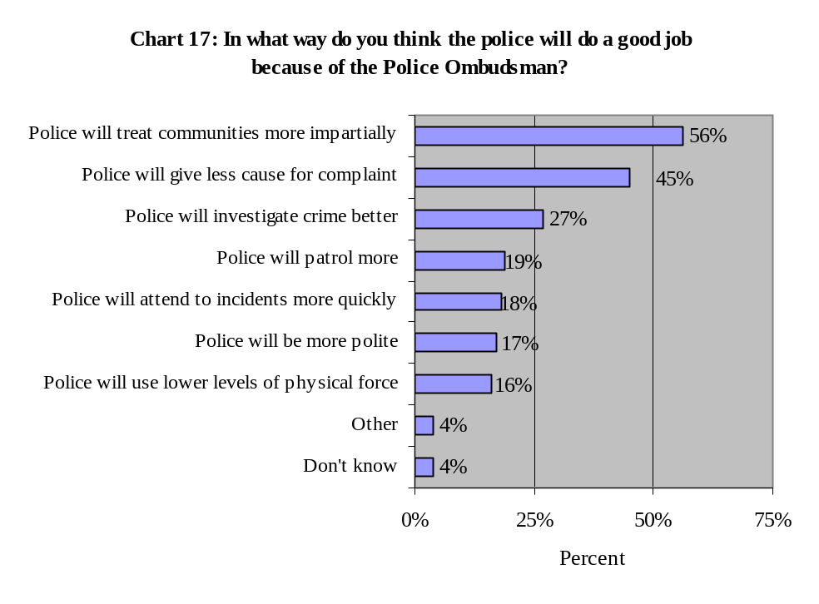
The results across the two communities are relatively similar in terms of ranking, and there is little difference in terms of magnitude. The largest proportions on both sides of the community mirror the result found for all respondents.

Table 7: In what way will the police do a good job because of the Police Ombudsman by Community Background

 | Community Background
 | Catholic % | Protestant %
Police will treat all communities in Northern Ireland more impartially | 60 | 53
The police will give less cause for complaints from the public | 44 | 45
The police will investigate crime better | 25 | 29
The police will patrol more | 14 | 23
The police will attend to incidents more quickly | 13 | 21
The police will be more polite | 15 | 18
The police will use less physical force | 17 | 15
Other | 6 | 4
Don’t know | 3 | 5
(Note: Percentages add to more than 100% as respondents could give more than one response)

Appendix:

Survey Questions

Has a police officer ever behaved towards you in a way that you thought was unacceptable?

Yes – once or twice
Yes – more than once or twice
No
Don’t know/refused/no answer

- (If yes at 1) Thinking about the most recent incident, what did the police officer do that you thought was unacceptable?

The officer was violent towards you (for example, pushed or struck you)
The officer was disrespectful or impolite to you
The officer swore at you
The officer used sectarian, racist or sexist language when dealing with you
The officer didn’t do his/her duty properly (for example, by not investigating the crime properly or not responding to a call)
The officer harassed you
The officer didn’t follow proper procedures
The officer stopped or searched you without reason
The officer searched your house without reason
The officer said you had done something you hadn’t
The officer took an item of your property
The officer discriminated against you (for example, because of your race, gender, age or religion)
Other (please specify)
Don’t know/refused/no answer

- (If yes at 1) Thinking again about the most recent incident, did you make a complaint about this?

Yes
No
Don’t know/refused/no answer

- (If no at 3) What was the main reason you didn’t make a complaint about this?

Felt it would not be taken seriously
Felt nothing would be done about it
Incident was not serious enough
Couldn’t be bothered
Scared of police reprisals
Didn’t want to make trouble for the police
Forgot
Didn’t know how to complain about police behaviour
Other (please specify)
Don’t know/refused/no answer

- If you wanted to make a complaint against the police, were would you go first of all? (code one only)

Local police station
Solicitor
The Police Ombudsman
The Chief Constable of the PSNI
Your MP/MLA
A local politician (for example, councillor)
The Citizen’s Advice Bureau
The Policing Board
Wouldn’t make a complaint
Other (please specify)
Don’t know/refused/no answer

- Have you heard of the Police Ombudsman for Northern Ireland?

Yes
No
Don’t know/refused/no answer

- (If yes at 6) How did you hear of the Police Ombudsman for Northern Ireland? (code all that apply)

Television
Radio
Newspaper/Magazine
Through work
Word of mouth
Friends/Family
Internet
Leaflets
Posters
Attended a presentation about the Police Ombudsman
Other (please specify)
Don’t know/refused/no answer

- Do you think the Police Ombudsman for Northern Ireland is part of the police or independent of the police?

Part of the police
Independent of the police
Don’t know/refused/no answer

- How confident are you that the Police Ombudsman deals with complaints against the police in an impartial way?

Very confident
Fairly confident
Not very confident
Not at all confident
Don’t know/refused/no answer

- If you needed to contact the Office of the Police Ombudsman where would you go to find the relevant contact details?

Telephone directory
Internet
Call personally at the Office of the Police Ombudsman
Directory enquiries
Advice agency
Political representative
Legal representative
Police station
Community association
Other

- If you were to make a complaint against a police officer to the Police Ombudsman, do you think that you would be treated fairly?

Yes
No
Don’t know/refused/no answer

- If you made a complaint against a police officer, do you think the police officer would be treated fairly?

Yes
No
Don’t know/refused/no answer

- (If no to 11 or 12) Do you think the Police Ombudsman treats the person making the complaint better or the police officer being complained about better?

Treats the person making the complaint much better
Treats the person making the complaint slightly better
Treats the police officer being complained about slightly better
Treats the police officer being complained about much better
Don’t know/refused/no answer

- Do you think the Police Ombudsman for Northern Ireland will help ensure that the police do a good job?

Yes
No
Don’t know/refused/no answer

- In what way do you think the police will do a good job because of the Police Ombudsman?

The police will be more polite
The police will attend to incidents more quickly
The police will treat all communities in Northern Ireland more impartially
The police will investigate crime better
The police will use less physical force
The police will patrol more
The police will give less cause for complaints from the public
Other (please specify)
Don’t know/refused/no answer

